QUALITY ASSESSMENT OF BEHAIRA GOVERNORATE GROUND WATER (EL-DELENGATE DISTRICT) BY CHEMICAL AND HEAVY METAL ANALYSIS
El-Sanafawy- Hamida, M.A.; N.I. Talha, S.A. El-Saady and A.A.S. Gendy
Soil, Water and Environmental Res. inst., ARC, Cairo, Egypt
ABSTRACT
The scarcity of water makes it difficult and expensive to expand the cultivated land, or even protect soil with natural cover. In Egypt, there is a growing concern that the very limited water resources are becoming increasingly polluted because of the misuse and improper management of resources, which jeopardizes any attempt for sustainable agriculture development. The overall objective of this research was to assess the ground water resources quality for an agroecological system in Behaira governorate. To achieve this objective, water samples of 59 well at depth’s 15 to 40 m were taken and chemical as well as heavy metal analyses revealed that:
- pH values varied from slightly alkaline to alkaline.
- Sodium cation was the dominant followed by magnesium and calcium. On the other hand, chloride and sulphate were the dominant anions.
- Adj. SAR of ground water samples studied showed that 30 samples suitable for irrigation purposes, whereas 10 samples may cause permeability problem of soil, and 19 samples were unsuitable for irrigation purposes.
- According to USDA diagram, the majority of the studied water samples were in class C₃S₁ (slightly dangerous for irrigation purposes. The rest of ground water samples were in class C₄S₃ and C₃S₂ (highly and medium sodium content and very high saline with high sodium content), so such water are not suitable for irrigation for soils under ordinary condition.
- Heavy metal content in the studied ground water samples can be arranged according to their contents in the order: Cu>Pb>Fe>Mn>Cd>Ni. Also, the concentration of Fe, Mn, Pb were lower than the permissible limits for irrigation water according to FAO, 1985. Ni and Cu concentration generally were within the permissible limits FAO, 1985. But Cd concentration was much higher than the permissible limits of FAO, 1985.
Keywords: Water resources, quality assessment water salinity, heavy metals.
INTRODUCTION
The key for future is to develop sustainable farming system, which maintain acceptable yields, while causing minimal pollution to the environment (El-Bana et al., 2006). The production of grain and protein has increased so dramatically since the industrialization of agricultural systems in the 1950s, that supply now exceeds demand in most developed countries. This made only possible through the agricultural intensification and the extensive use of agrochemicals (i.e. fertilizers and pesticides). This has drawn public, political and research attention from sources of food supply and security to those of maintaining or improving environmental quality (National Research, Council, 2000). Water resources in Egypt are becoming the forefront issue and the main constraints for any agricultural expansion where the Egyptian agricultural depends mainly on irrigation from the River Nile. FAO (1992) reported that in facing increasing water needs demanded by a rapidly growing population, by increased urbanization by higher standards of living and by an agricultural policy in which emphasize expand production in order to feed the growing population. This compels the policy makers to use all sources of water, conventional and non-conventional (i.e. ground water, drainage water and treated sewage effluents) for the expansion of irrigated agriculture. So that the Ministry of Public Works and Water Resources recycles about 5 billion m³ of drainage water officially and its goal is to increase the volume to 7 billion m³ (Abu-Zeid, 1992; Abu Zeid and Hefny, 1992; Wilardson et al. , 1997 and Kotb et al. , 2000).
Direct use of drainage water for irrigation with salinity from 2 to 3 dS/m is common in the districts of Northern Delta (Mashali, 1985). Investigation of water quality have focused mainly on chemical assessment (Abbas et al. , 1993; Avila and Alarcon, 2003 and Ayers and Westcot, 1985), U.S. salinity Laboratory staff (1954) had proposed diagram for evaluating waters for irrigation on the bases of SAR and EC (dS/m). According to Ayers and Westcot (1985), water quality refers to characteristics of water supply that will influence its suitability for specific use.
It is generally agreed with that the irrigation water is one of the waters most precious resources, particularly in semi arid and arid areas, as in the case with Egypt (El-Gendi, 2003). The provision of irrigation water is one of the most important factors for the expansion of agriculture production; FAO irrigation paper No. 29 (1985) stated that the River Nile is Egypt’s sole source of surface water. But under the pressing need for increasing of agricultural production, they used low quality waters for irrigation (e.g. ground water, and/or sewage effluent water). These waters often contain some of trace metals, which exist from a variety of sources. Some of trace metals (e.g. Zn, Co, Cu, Mo, Fe) are nutrient and act as enzyme activators. Others are highly toxic (e.g. Cd, Pb, As). Some of the nutrient elements (e.g. Zn, Cu) may be toxic at elevated concentrations (Cottenie et al., 1979; Abouroos et al. , 1991 and More and Gschwend, 1987). Therefore, these metals must be carefully monitored and controlled.
The depth and salinity of ground water in North Nile Delta soils has been discussed in previous studies. The present work is carried out mainly to through light on the levels of some heavy metals in the ground water of the Mid Nile Delta soils. Ground water could be considered as a potential irrigation water supply on condition that their contents of dissolved salts and trace elements are permissible. The present study also deals with ground water quality concerning the level of some heavy metals (Cu, Mn, Cd, Pb and Ni).
MATERIALS AND METHODS
Monitoring area:
The area is located in Behaira governorate; El-Delengat district. The site is located at 30º 50⁻ 19⁼ latitude and 30º31⁻20.68⁼ longitude, with an elevation of about 3 meters above mean sea level. Map 1 illustrates the location of the monitoring area. Each sampling location was geolocates according to Agriculture Extension
Water sampling:
Fifty nine ground water samples (Map. 1 and Table 1) were taken from the studied area (El-Delengate district) at depths from 15 to 40 m in July 2009 soluble cations (Ca⁺⁺, Mg⁺⁺, Na⁺ and K⁺), soluble anions (CO₃⁻⁻, HCO₃⁻ Cl⁻ and SO₄⁻⁻), pH and EC as well as were measured SAR and Adj SAR were calculated, thus, water quality class was defined according to salinity laboratory staff (1954) proposed diagram for evaluating waters for irrigation on the basis of SAR and EC (dS/m).

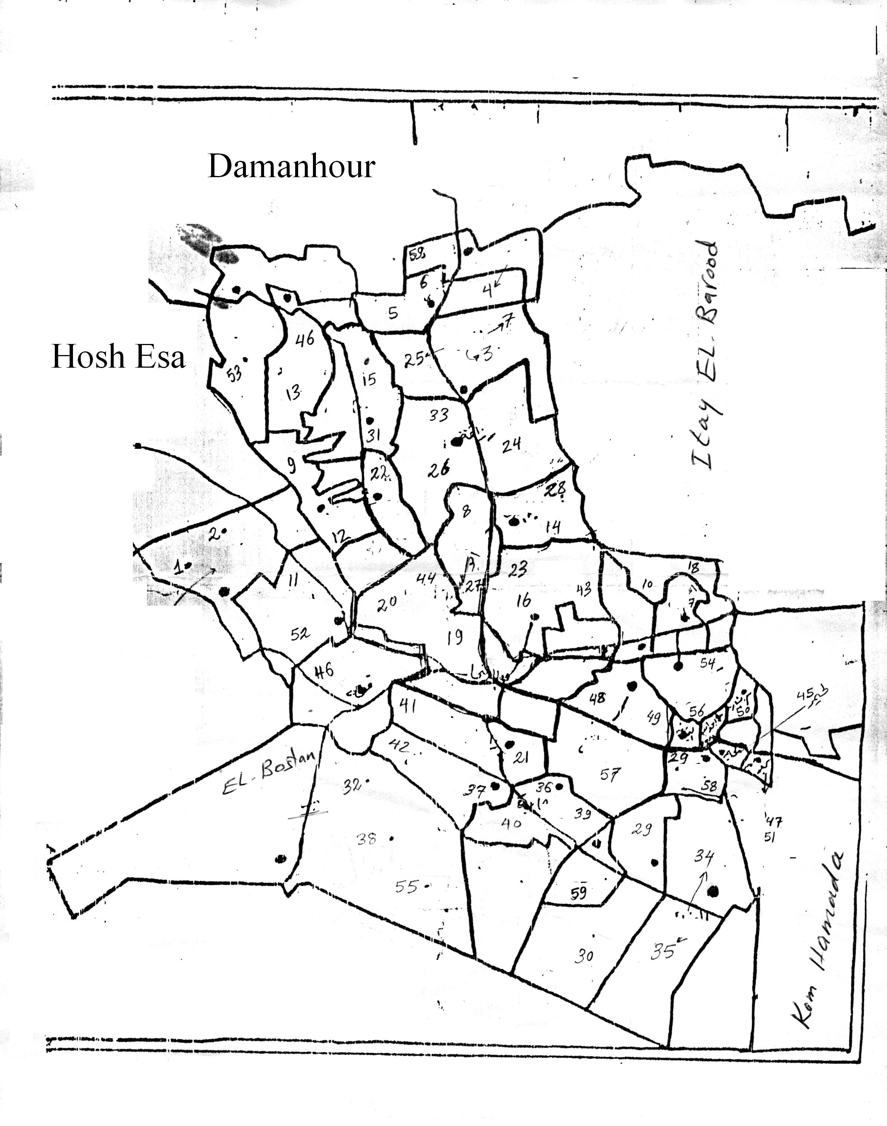
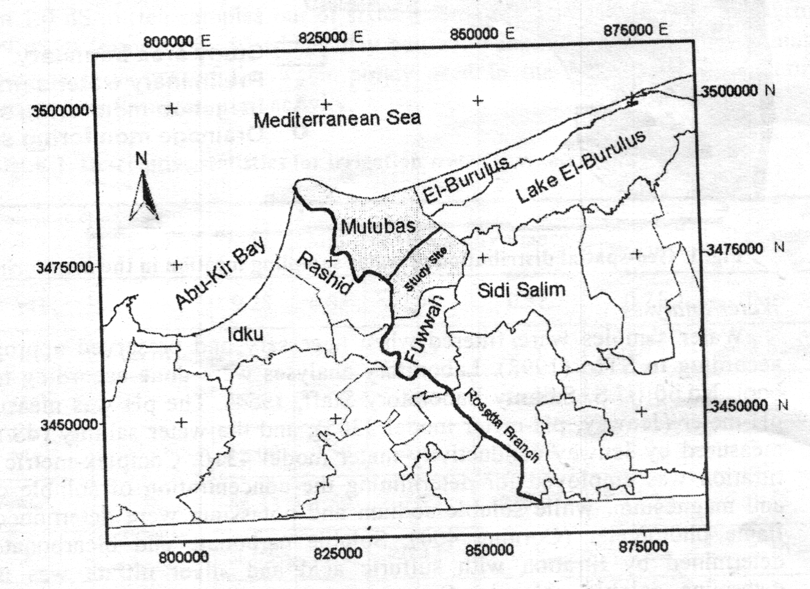

- Sampling locations

Map 1: Location of the monitoring area (El-Delengat district)

Soluble heavy metals in ground water, Cd, Pb, Ni, Cu and Mn were determined using the standard methods described by American Public Health Association (APHA, 1971), where the collected ground water samples were filtered and evaporated under vacuum in a water path until dryness. The residues were soaked with 10 ml aqua regia and digested then heavy metals were measured using Atomic Adsorption Spectrophotometer (Perkin Elmer 3300).

Table (1): Location of the monitoring area
W₁ | Zaweit Hammour | W₃₁ | El-Higr El-Mahrouk
W₂ | Zaweit Hammour | W₃₂ | El-Bostan
W₃ | El-Mesien | W₃₃ | Rozzafa
W₄ | Abo-Masoud | W₃₄ | El-Wafaeya
W₅ | Atlameis | W₃₅ | El-Wafaeya
W₆ | Atlameis | W₃₆ | Dershaba
W₇ | El-Mesien | W₃₇ | Manshiet Fadel
W₈ | Abo-Seita | W₃₈ | El-Bostan
W₉ | El-Kheleiya | W₃₉ | Dershaba
W₁₀ | Gazayer Eisa | W₄₀ | Dershaba
W₁₁ | Teba | W₄₁ | Zaweit Abo-Shosha
W₁₂ | El-Kheleliya | W₄₂ | Manshiet Fadel
W₁₃ | Shirket El-Etehad | W₄₃ | Ebia El-Hamra
W₁₄ | Abo-Wafiya El-Kobra | W₄₄ | El-Delengat
W₁₅ | El-Hegr El-Mahrouk | W₄₅ | Lehaimer
W₁₆ | Ebia El-Hamra | W₄₆ | Khamha
W₁₇ | El-Margrahy | W₄₇ | Kafr Lehaimer
W₁₈ | Gazayer Eisa | W₄₈ | Zemran El-Nakhl
W₁₉ | El-Delengat | W₄₉ | Zemran El-Nakhl
W₂₀ | El-Delengat | W₅₀ | M. Bishara
W₂₁ | Zaweit Abo-Shosha | W₅₁ | Kafr Lehaimer
W₂₂ | El-Alamiya | W₅₂ | Teba
W₂₃ | Ebia El-Hamra | W₅₃ | El-Manshiya El-Gideda
W₂₄ | Rozzafa | W₅₄ | Kom Zemran
W₂₅ | El-Mesien | W₅₅ | El-Bostan
W₂₆ | Rozzafa | W₅₆ | Kom Zemran
W₂₇ | Abo-Seifa | W₅₈ | Zemran El-Nakhl
W₂₈ | Abo-Wafiya El-Kobra | W₅₈ | Abo Hamada
W₂₉ | Zohor El-Omara | W₅₉ | Abo Masoud
W₃₀ | Zohor El-Omara

RESULTS AND DISCUSSION
Salinity and sodicity:
Table (2) shows that generally, pH values exhibited by most of the location of ground water samples seem to be slightly alkaline to alkaline 7.33 at location W59 to 8.80 at location W48.
Data in the same table revealed that EC values ranged from 0.26 to 3.41 dS/m at locations W44 and W38.
Ground water level rises just below the soil surface in North area of Nile delta, its soluble salts increase. The increase in soluble salts in the ground water is mainly ascribed to the inflow and contamination with the saline water, through the seepage from Mediterranean sea water in the North area of Delta region. The salinity of the ground water might also be affected by some factors such as land use, crop pattern, soil management and drainage efficiency.

Table (2): Chemical composition of studied ground water samples of El-Delengate district, Behaira governorate.
Location | EC  dS/m | pH | Anions (meq/L) |  |  |  | Cations (meq/L) |  |  |  | SAR | Adj  SAR
Location | EC  dS/m | pH | CO₃⁻⁻ | HCO₃⁻ | Cl⁻ | SO₄⁻⁻ | Ca⁺⁺ | Mg⁺⁺ | Na⁺² | K⁺ | SAR | Adj  SAR
W1 | 3.07 | 7.88 | 0.50 | 4.00 | 15.36 | 11.59 | 3.40 | 4.01 | 3.84 | 0.20 | 12.39 | 27.85
W2 | 2.34 | 8.00 | 0.50 | 4.50 | 14.21 | 2.51 | 4.60 | 1.29 | 15.62 | 0.21 | 9.10 | 21.12
W3 | 0.59 | 8.30 | 1.25 | 2.25 | 1.92 | 0.98 | 1.60 | 1.63 | 3.00 | 0.17 | 2.36 | 5.12
W4 | 0.99 | 8.43 | 1.50 | 4.75 | 2.30 | 1.39 | 2.00 | 1.23 | 6.56 | 0.15 | 5.16 | 10.79
W5 | 0.72 | 8.02 | 0.50 | 3.75 | 2.88 | 0.25 | 2.00 | 1.42 | 3.69 | 0.27 | 2.82 | 6.77
W6 | 0.70 | 7.78 | 0.50 | 5.25 | 1.73 | 0.82 | 2.60 | 3.10 | 2.40 | 0.20 | 1.42 | 2.29
W7 | 0.47 | 7.68 | 0.50 | 2.50 | 0.96 | 0.93 | 1.70 | 1.67 | 1.40 | 0.12 | 1.08 | 2.37
W8 | 0.86 | 7.55 | 1.00 | 5.25 | 2.50 | 0.52 | 2.00 | 3.89 | 3.12 | 0.26 | 1.82 | 4.35
W9 | 1.00 | 7.42 | 0.50 | 6.75 | 2.30 | 1.46 | 2.60 | 4.81 | 3.44 | 0.16 | 1.79 | 4.19
W10 | 0.40 | 7.86 | 0.50 | 2.50 | 1.15 | 1.30 | 2.00 | 1.61 | 1.72 | 0.12 | 1.28 | 2.49
W11 | 1.23 | 7.90 | 1.00 | 4.00 | 5.95 | 1.40 | 2.00 | 2.94 | 7.20 | 0.21 | 4.58 | 10.49
W12 | 1.09 | 7.93 | 0.50 | 4.50 | 5.18 | 1.33 | 1.60 | 2.77 | 6.96 | 0.18 | 4.71 | 10.78
W13 | 1.57 | 7.60 | 0.50 | 4.50 | 7.10 | 5.00 | 5.00 | 5.45 | 6.30 | 0.35 | 2.76 | 7.39
W14 | 0.62 | 8.07 | 1.00 | 3.75 | 2.50 | 0.19 | 2.60 | 2.34 | 2.24 | 0.26 | 1.43 | 3.18
W15 | 1.02 | 8.35 | 2.50 | 5.00 | 3.46 | 0.57 | 3.00 | 2.89 | 5.36 | 0.28 | 3.12 | 7.40
W16 | 0.66 | 7.73 | 1.00 | 4.25 | 1.92 | 1.04 | 2.80 | 2.33 | 2.82 | 0.26 | 1.76 | 4.10
W17 | 0.54 | 8.00 | 0.50 | 2.50 | 2.07 | 1.17 | 2.40 | 1.78 | 1.88 | 0.18 | 1.30 | 2.98
W18 | 0.47 | 8.02 | 0.50 | 2.25 | 2.07 | 0.37 | 1.80 | 1.24 | 2.00 | 0.15 | 1.62 | 3.59
W19 | 1.26 | 8.10 | 1.00 | 4.25 | 5.95 | 1.95 | 1.20 | 2.41 | 9.42 | 0.12 | 7.01 | 10.22
W20 | 1.36 | 7.74 | 1.50 | 5.50 | 6.72 | 0.08 | 1.80 | 3.33 | 8.52 | 0.15 | 5.32 | 12.50
W21 | 1.44 | 7.46 | 1.00 | 6.50 | 6.34 | 1.32 | 2.80 | 4.23 | 8.04 | 0.09 | 4.29 | 10.08
W22 | 0.82 | 7.60 | 1.25 | 3.50 | 3.26 | 0.49 | 2.00 | 2.13 | 4.20 | 0.17 | 2.92 | 6.53
W23 | 0.59 | 7.68 | 0.75 | 2.75 | 1.92 | 0.54 | 2.00 | 1.37 | 2.46 | 0.13 | 1.90 | 4.13
W24 | 0.76 | 7.82 | 1.5 | 3.50 | 2.50 | 2.07 | 3.40 | 2.30 | 3.69 | 0.18 | 2.19 | 5.49
W25 | 1.02 | 8.17 | 1.0 | 4.00 | 2.69 | 3.24 | 1.20 | 1.84 | 7.04 | 0.85 | 5.71 | 11.99
W26 | 0.93 | 7.55 | 0.5 | 5.75 | 2.30 | 4.04 | 2.80 | 1.95 | 7.60 | 0.24 | 4.93 | 11.02
W27 | 0.79 | 7.83 | 1.0 | 4.25 | 2.30 | 0.93 | 2.80 | 2.90 | 2.60 | 0.18 | 1.54 | 3.65
W28 | 0.55 | 8.15 | 0.50 | 2.25 | 1.50 | 0.92 | 2.10 | 1.37 | 1.60 | 0.10 | 1.22 | 2.80
W29 | 0.37 | 8.30 | 0.50 | 1.75 | 0.96 | 0.49 | 1.10 | 0.85 | 1.56 | 0.19 | 1.58 | 3.22
W30 | 0.55 | 8.24 | 0.50 | 2.25 | 2.50 | 0.53 | 1.40 | 1.16 | 3.10 | 0.12 | 2.74 | 5.75
W31 | 1.39 | 7.72 | 1.00 | 1.75 | 9.41 | 2.16 | 5.40 | 3.91 | 4.80 | 0.21 | 2.23 | 5.74
W32 | 2.42 | 7.47 | 0.50 | 2.75 | 13.82 | 7.83 | 9.60 | 6.17 | 8.80 | 0.33 | 3.13 | 8.62
W33 | 0.76 | 8.17 | 1.00 | 3.50 | 2.30 | 0.84 | 1.20 | 2.98 | 3.20 | 0.26 | 2.21 | 5.18
W34 | 0.89 | 8.12 | 1.00 | 4.50 | 2.03 | 1.19 | 1.20 | 4.31 | 2.80 | 0.41 | 1.69 | 3.90
W35 | 0.86 | 8.54 | 1.25 | 2.50 | 3.46 | 1.46 | 0.80 | 0.91 | 6.88 | 0.08 | 7.44 | 14.44
W36 | 0.84 | 8.35 | 2.00 | 4.75 | 2.11 | 2.53 | 1.40 | 3.92 | 6.00 | 0.07 | 3.68 | 8.39
W37 | 1.08 | 8.36 | 1.00 | 3.50 | 5.16 | 1.40 | 0.80 | 1.48 | 8.68 | 0.10 | 8.13 | 16.34
W38 | 3.41 | 7.37 | 1.00 | 3.50 | 27.07 | 5.25 | 9.40 | 9.22 | 18.04 | 0.16 | 5.91 | 16.26
W39 | 1.23 | 8.32 | 1.50 | 4.50 | 2.88 | 2.86 | 1.20 | 3.74 | 6.30 | 0.50 | 4.01 | 9.18
W40 | 1.30 | 7.80 | 1.50 | 6.50 | 3.07 | 2.37 | 2.00 | 4.65 | 6.30 | 0.49 | 3.46 | 8.08
W41 | 1.66 | 7.97 | 1.50 | 6.50 | 4.22 | 4.44 | 1.80 | 4.85 | 9.42 | 0.59 | 5.17 | 12.09
W42 | 1.61 | 8.34 | 1.50 | 4.75 | 4.61 | 5.48 | 1.40 | 4.30 | 10.08 | 0.56 | 5.97 | 14.09
W43 | 0.30 | 8.42 | 0.75 | 1.25 | 1.40 | 0.72 | 1.20 | 0.32 | 2.54 | 0.06 | 2.91 | 5.62
W44 | 0.26 | 8.15 | 1.00 | 1.25 | 0.98 | 0.32 | 1.20 | 0.13 | 2.17 | 0.05 | 2.66 | 5.16
W45 | 0.30 | 8.24 | 1.50 | 1.50 | 0.58 | 1.09 | 1.20 | 0.51 | 2.89 | 0.07 | 3.13 | 5.97
W46 | 1.52 | 7.55 | 1.00 | 6.75 | 6.91 | 1.46 | 2.40 | 2.73 | 10.86 | 0.13 | 6.78 | 15.94
W47 | 0.59 | 7.48 | 1.00 | 3.50 | 1.54 | 0.91 | 2.00 | 2.18 | 2.68 | 0.09 | 1.85 | 4.36
W48 | 0.36 | 8.80 | 1.25 | 1.50 | 1.54 | 0.75 | 0.60 | 1.11 | 3.25 | 0.08 | 3.52 | 6.68
W49 | 0.45 | 7.92 | 1.00 | 2.25 | 1.25 | 0.86 | 1.40 | 1.64 | 2.16 | 0.16 | 1.75 | 3.80
W50 | 0.36 | 8.64 | 1.00 | 1.75 | 1.54 | 0.60 | 0.60 | 1.11 | 3.10 | 0.08 | 3.35 | 6.40
W51 | 0.38 | 8.13 | 1.00 | 1.75 | 1.23 | 0.67 | 2.40 | 0.83 | 1.36 | 0.06 | 1.07 | 2.47
W52 | 1.45 | 7.73 | 1.00 | 3.25 | 7.30 | 4.39 | 5.40 | 4.48 | 6.00 | 0.06 | 2.70 | 7.29
W53 | 2.21 | 7.29 | 1.00 | 4.00 | 10.37 | 7.91 | 7.80 | 6.83 | 8.58 | 0.07 | 3.17 | 2.26
W54 | 0.50 | 7.99 | 1.00 | 2.75 | 0.96 | 1.14 | 3.00 | 1.18 | 1.44 | 0.23 | 1.00 | 2.26
W55 | 1.95 | 7.40 | 1.50 | 4.50 | 11.50 | 4.31 | 2.80 | 4.99 | 13.80 | 0.22 | 6.99 | 16.15
W56 | 0.46 | 7.73 | 1.00 | 3.50 | 0.58 | 0.81 | 3.00 | 1.18 | 1.56 | 0.15 | 1.08 | 2.44
W57 | 0.50 | 7.87 | 1.00 | 2.25 | 1.34 | 0.94 | 2.90 | 1.16 | 1.30 | 0.17 | 0.91 | 2.20
W58 | 0.32 | 7.77 | 0.50 | 2.25 | 0.86 | 0.69 | 2.40 | 0.64 | 1.00 | 0.26 | 0.81 | 1.88
W59 | 1.79 | 7.33 | 0.50 | 3.50 | 7.10 | 8.28 | 7.60 | 4.37 | 7.20 | 0.21 | 2.94 | 4.83

Data in the same table indicate that the chloride dominates sulphate and carbonate anions in the order: Cl⁻>SO₄⁼>HCO₃⁻. These anions are associated
with Na⁺, Mg⁺⁺ and Ca⁺⁺. It is also noticed that magnesium exceeds calcium throughout the most studied locations. Calcium and magnesium ions in the ground water are mainly in the form of magnesium and calcium sulphates. The behaviour is in a good harmony with the results obtained by Kholie et al. (1989), Zein et al. (1998) and El-Sanafawy (2002).
Generally adj SAR concept of FAO, suggest that water have less than 6 suitable as dominant clay minerals without any problem. On the other hand, the use of irrigation water having adjusted from 6-9 cause permeability problem of soil water with adjusted SAR value more than unsuitable for irrigation.
Generally adjusted SAR determined for the studied groundwater samples were considered to be suitable for irrigation purposes in 30 samples while 10 samples may cause permeability problem of soils, and 19 samples were unsuitable for irrigation purposes.
According to USDA diagram the majority of the studied samples are in class C₃S₁ with SAR values ranged from 12.39 to 0.81. Therefore, this water is considered slightly dangerous for irrigation purposes. The rest of ground water samples W₁ (12.39%) and W₂ (9.10) were in class C₄S₃ and C₃S₂. According to U.S. Salinity laboratory (1954) classification C₃S₂ Class water is high saline and medium sodium content. Such water can be used with restricted drainage even with adequate drainage, special management for salinity control may be required, and plant with good salt tolerance selected. Sodium was present in appreciable sodium hazard in fine textured soils having high cation exchange capacity, specially under low leaching conditions, unless gypsum present in the soil. Such water may be used on course textured or organic soil with good permeability, class C₄S₃ indicate that the water are very high saline with high sodium content. These water are not suitable for irrigation for soils under ordinary conditions but may be used occasionally under very special circumstances. The soils must be permeable, drainage must be adequate, irrigation water must be applied in excess, to provide considerably leaching and highly salt tolerant crops should be selected. From the view point of sodium hazard this water may produce harmful levels of exchangeable sodium in most soil and will requires special management, good drainage, high leaching and organic matter additions. Chemical amendments may be required for replacement of exchangeable sodium, except that amendments may be feasible with waters at very high salinity.
Heavy metals:
Concentration of heavy metals in the studied ground water samples shown in Table (3) and Fig. (1) revealed that the content of Fe ranged from 0.169 (W22) to 0.874 (W30), Mn from 0.11 (W16) to 0.2345 (W4), Cu from 0.28 (W7) o 1.787 (W11), Pb from 0.435 (W16) to 1.558 (W49), Ni from 0.015 (W35) to 0.166 (W26) and Cd from 0.016 (W19) to 0.199 mg/kg W54 and W58.

Table 3: Heavy metal content of studied ground water samples.
Location | Fe | Mn | Cu | Pb | Ni | Cd
W1 | 0.56 | 0.14 | 0.06 | 0.75 | 0.09 | 0.09
W2 | 0.51 | 0.09 | 0.04 | 0.92 | 0.06 | 0.15
W3 | 0.52 | 0.14 | 0.05 | 0.83 | 0.07 | 0.13
W4 | 0.61 | 0.23 | 0.08 | 1.14 | 0.14 | 0.13
W5 | 0.50 | 0.05 | 0.07 | 1.14 | 0.12 | 0.20
W6 | 0.38 | 0.10 | 0.03 | 0.51 | 0.12 | 0.17
W7 | 0.40 | 0.08 | 0.03 | 0.74 | 0.07 | 0.11
W8 | 0.42 | 0.04 | 0.06 | 0.62 | 0.07 | 0.15
W9 | 0.32 | 0.04 | 0.07 | 0.73 | 0.02 | 0.02
W10 | 0.19 | 0.04 | 0.06 | 0.55 | 0.03 | 0.07
W11 | 0.29 | 0.05 | 1.79 | 0.75 | 0.10 | 0.05
W12 | 0.42 | 0.10 | 0.08 | 0.80 | 0.06 | 0.05
W13 | 0.49 | 0.08 | 0.11 | 0.85 | 0.12 | 0.08
W14 | 0.37 | 0.06 | 0.15 | 0.73 | 0.12 | 0.11
W15 | 0.42 | 0.02 | 0.08 | 0.56 | 0.05 | 0.20
W16 | 0.30 | 0.01 | 0.06 | 0.45 | 0.07 | 0.10
W17 | 0.50 | 0.08 | 0.15 | 0.98 | 0.07 | 0.08
W18 | 0.30 | 0.06 | 0.16 | 0.87 | 0.13 | 0.15
W19 | 0.37 | 0.08 | 0.09 | 0.80 | 0.11 | 0.02
W20 | 0.37 | 0.07 | 0.10 | 0.91 | 0.10 | 0.05
W21 | 0.27 | 0.04 | 0.05 | 0.69 | 0.06 | 0.03
W22 | 0.17 | 0.04 | 0.08 | 0.75 | 0.14 | 0.18
W23 | 0.25 | 0.06 | 0.10 | 0.89 | 0.04 | 0.08
W24 | 0.33 | 0.04 | 0.09 | 0.67 | 0.07 | 0.06
W25 | 0.22 | 0.06 | 0.10 | 0.61 | 0.08 | 0.19
W26 | 0.38 | 0.04 | 0.09 | 0.90 | 0.17 | 0.09
W27 | 0.31 | 0.03 | 0.10 | 0.77 | 0.04 | 0.06
W28 | 0.34 | 0.06 | 0.08 | 0.66 | 0.11 | 0.03
W29 | 0.42 | 0.05 | 0.11 | 0.84 | 0.09 | 0.04
W30 | 0.87 | 0.12 | 0.11 | 1.39 | 0.14 | 0.19
W31 | 0.42 | 0.08 | 0.09 | 0.62 | 0.05 | 0.02
W32 | 0.38 | 0.06 | 0.09 | 0.76 | 0.07 | 0.12
W33 | 0.47 | 0.08 | 0.09 | 0.80 | 0.05 | 0.11
W34 | 0.31 | 0.06 | 0.10 | 1.07 | 0.03 | 0.06
W35 | 0.33 | 0.06 | 0.08 | 0.84 | 0.02 | 0.10
W36 | 0.51 | 0.12 | 0.14 | 1.04 | 0.06 | 0.14
W37 | 0.59 | 0.11 | 0.14 | 1.12 | 0.03 | 0.08
W38 | 0.59 | 0.10 | 0.14 | 1.08 | 0.08 | 0.03
W39 | 0.57 | 0.11 | 0.17 | 1.32 | 0.10 | 0.09
W40 | 0.60 | 0.12 | 0.16 | 1.27 | 0.10 | 0.13
W41 | 0.38 | 0.06 | 0.08 | 0.48 | 0.03 | 0.12
W42 | 0.48 | 0.05 | 0.06 | 0.49 | 0.01 | 0.04
W43 | 0.43 | 0.06 | 0.08 | 0.67 | 0.02 | 0.16
W44 | 0.54 | 0.11 | 0.16 | 1.16 | 0.11 | 0.05
W45 | 0.48 | 0.15 | 0.15 | 1.13 | 0.09 | 0.05
W46 | 0.42 | 0.06 | 0.06 | 0.83 | 0.07 | 0.12
W47 | 0.50 | 0.06 | 0.08 | 1.06 | 0.06 | 0.05
W48 | 0.29 | 0.03 | 0.05 | 0.59 | 0.09 | 0.12
W49 | 0.76 | 0.15 | 0.21 | 1.56 | 0.10 | 0.02
W50 | 0.39 | 0.05 | 0.08 | 0.78 | 0.07 | 0.09
W51 | 0.57 | 0.10 | 0.15 | 1.24 | 0.14 | 0.19
W52 | 0.43 | 0.06 | 0.09 | 0.75 | 0.05 | 0.12
W53 | 0.70 | 0.13 | 0.13 | 1.13 | 0.09 | 0.13
W54 | 0.49 | 0.06 | 0.10 | 1.04 | 0.06 | 0.15
W55 | 0.47 | 0.08 | 0.12 | 0.74 | 0.06 | 0.07
W56 | 0.43 | 0.16 | 0.11 | 0.73 | 0.02 | 0.02
W57 | 0.67 | 0.14 | 0.21 | 1.42 | 0.12 | 0.11
W58 | 0.57 | 0.09 | 0.16 | 1.33 | 0.14 | 0.20
W59 | 0.66 | 0.14 | 0.27 | 0.73 | 0.03 | 0.02
FAO* | 5.0 | 0.20 | 2.0 | 5.00 | 0.20 | 0.01
* Permissible maximum concentration in irrigation water adapted from FAO (1985)
Fig (1): Heavy metal content of studied ground water samples

Fig. (1): Cont.

El-Araby and El-Lbordiny (2006) and Abd El-Hady (2007), reported that irrigation by ground water which contain little or medium amounts of heavy metals will contaminate the soil and crops that will be risky for human and animal health (Zein et al., 2009 and Gaafer et al., 2009).
Enb et al. (2009) showed the same results as in canola plants and cows and buffaloes animals.
Zein et al. (2002) showed that jews mallow, rocket and cabbage irrigated with polluted water were highest in their heavy metals content.
Data indicate the enrichment show also that such heavy metals could be arranged according to their content in the studied ground water samples in the order Cu>Pb>Fe>Mn>Cd>Bu, El-Sanafawy (2005) found that the orders of heavy metals in Mid Nile Delta region were Zn>Cu>Mn>Ni>Pb>Cd. Data indicate the enrichment of ground water of Behaira governorate in Cu & Pb than Mid Nile Delta region.
Data also showed that the concentration of Fe, Mn and Pb were lower than the permissible limits of irrigation water (FAO, 1985) while the concentrations of Ni and Cu generally, lower than the permissible limit of FAO (1985). Cd content was higher than the permissible limit of FAO (1985) for ground water. This means that the quality of the studied Behaira governorate (e district) ground water is deteriorating, therefore, a comprehensive, therefore, protection policy is needed for sustainable use of water.
REFERENCES
Abbas, M.Z.M.; Brns, R.E.; Searminio, I.S. and Ferreira, J.R. (1993). A multivariate statistical analysis of the composition of rain water near Cubato, Sp. Brasil. Environ. Pollut., 79, 225.
Abd El-Hady, B.A. (2007). Compare the effect of polluted and river Nile irrigation water on contents of heavy metals of some soils and plants. Res. J. Agric. and Biol. Sci., 3: 278.
Aboulroos, A.S.; Holah, Sh.Sh.; El-Kerbawy, I.M. and Badawy, H.E. (1991). Fractionation of some heavy metals in soils irrigated with sewage effluent for different years. Egypt. J. Soil Sci.,, 31(1): 43.
Abu-Zeid, M. (1992). Water resources assessment for Egypt. Water Resources Dev., 8(2): 76.
Abu-Zeid, M. and Hefeny, K. (1992). Water resources assessment and management in Egypt during conditions of stress. World Meteoral Orga. Bull., 41: 35.
American Public Health Association (APHA) (1971). Standard method for examination of water and wastewater 1st ed., Washington 874 up.
Avila, A. and Alarcon, M. (2003). Precipitation chemistry at a rural Mediterranean site; between anthropogenic pollution and natural emission. J. Geophys. Res. 108: 4278.
Ayers, R.S. and Westcot, W. (1985). Water quality for agriculture. Irrigation and Drainage paper 29(Rev.). J. FAO, Rome, Italy.
Cottenie, A.; Camerlynck, A.; Verloo, M. and Dtaese, A. (1979). Fractionation and determination of trace elements in plants. Puve Appt. Chem. 52, 45.
El-Araby, A.M. and Ellbordiny, M.M. (2006). Impact of reused water for irrigation on availability of heavy metals on sandy soils and their uptake by plants. J. Appl. Sci. Res., 2: 106.
El-Bana, T.A.; Gaber, H.M.; Bahnassy, M.H. and Suliman, A.S. (2006). Quality Assessment of Water Resources in Northern Nile Delta: A case study in Kafr El-Sheikh Governorate. Egypt. J. Soil Sci., 46(4): 409-423.
El-Gendy, S.A.M. (2003). Speciation of some heavy metals in some waters of Egypt. Egypt. J. Soil Sci., 43(2): 211-221.
El-Sanafawy-Hamida, M. (2002). Geochemical investigation of soil and water on polluted areas in mid-Nile Delta environmental assessment. Ph.D. Thesis, Fac. Sci., Mansoura Univ., Egypt., p. 248.
El-Sanafawy-Hamida, M. (2005). Ground water heavy metals content in mid Nile Delta region. J. Agric. Sci. Mansoura Univ., 3(3): 1787-1794.
Enb, M.A.; Abou Donia, N.S.; Abd Rabou, A.A.K. and Elsenaity, M.H. (2009). Chemical composition of raw milk and heavy metal behaviour during processing of milk products. Global Veterinaria, 3: 268.
FAO (1992). The use of saline waters for crop production. Irrigation and drainage paper 48, Rome, Italy.
FAO (Food and Agricultural Organization) (1985). Water quality for agriculture Ed-Ayers, R.S. and Westcot D.W. FAO Irrigation and Drainage, Paper No. 29, Rew I., Rome, FAO, 147, p.
Gaafar, H.M.A.; Ghanem, G.H.A.; Bendary, M.M.; Zein, F.I.; Atwa, A.A.I. and El-Sanafawy-Hamida, M.A. (2009). Effect of polluted irrigation water on accumulation of some heavy metals in clay soil. Berseem and milk of cows and Buffaloes. Egypt. J. Nut. and Feeds 12(3): special Issue, 71-82.
Kholie, M.S.; Gobran O.A.; Abou Agwa, F.E. and Zein, F. (1989). Characteristics of groundwater in Nile Delta and their effect on soils and salinity under present conditions. Zagazig J. Agric. Res. 1611.
Kotb, T.; Watanabe, T.; Ogino, Y. and Tanji, K. (2000). Soil salinization in the Nile delta and related policy issues in Egypt. Agric. Water Manage, 43: 239.
Mashali, A.M. (1985). Amerlioration and development of deteriorated soils Egypt. Technical Report., Project FAO/UNDP Egy/79/020 Cairo, Egypt.
More, F.M.M. and Gschwend, P.M. (1987). The role of cloids in the partitioning of solutes in natural waters. In: W. Stumm (Ed.). Aquatic Surface Chemistry, Wiley, new York, pp. 405-422.
National Research Council (2000). Coastal waters: Understanding and reducing the effects of nutrient pollution. National Academy Press, Washington DC.
U.S. Salinity Laboratory Staff (1954). Diagnosis and Improvement of Saline and Alkali Soil. U.S. Dep., Agric., Handbook, No. 60.
Wilardson, L.S.; Boels, D. and Smedema, L.K. (1997). Reuse of drainage water from irrigated areas. Irrig. Drainage Syst., 11, 215.
Zein, F.I.; Hamida M.A. El-Sanafawy; N.I. Talkha and Salama Samia A. (2009). Using canola plant for phytoextracting heavy metals from soils irrigated with polluted drainage water for long term. J. Agric. Sci., Mansoura Univ., 34(6): 7309-7323.
Zein, F.I.; Hegab, O.A. and Elsanafawy-Hamida, M. (1998). Geochemical studies on some polluted soils in Kafr El-Sheikh Governorate Egypt. J. Agric. Sci. Mansoura Univ., 23(6): 2887-2918.
Zein, F.I.; Omar E.H., Abd-Alah M.A.A. and Elyamani M.S. (2002). Influence of irrigation water quality on heavy metals content of soils, water table and some crops at the Northern Nile Delta. Egypt. J. Soil Sci. 42(4): 739-750.
تقييم نوعية الماء الأرضى لمحافظة البحيرة مركز الدلنجات بالتحليل الكيماوى والعناصر الثقيلة
حميدة محمد أنور الصنفاوى ، ناصر ابراهيم طلحة ، صلاح عبد الرؤف السعدى والجندى عبد الرازق سليمان
معهد بحوث الأراضى والمياه والبيئة ـ مركز البحث الزراعية ـ الجيزة ـ مصر
إن ندرة الموارد المائية تؤدى الى صعوبة وزيادة التكلفة اللازمة للتوسع فى الاراضى الزراعية او على الأقل حماية الموارد الارضية بغطاء طبيعى فى مصر لذا يتزايد الاهتمام بمحدودية الموارد المائية المتاحة واحتمال التلوث لهذه المياه نتيجة لسوء الاستخدام أو لادارة هذه الموارد بطريقة غير سليمة.
وتهدف هذه الورقة البحثية الى تقييم الموارد المائية للنظام البيئى الزراعى لمركز الدلنجات بمحافظة البحيرة ولتحقيق هذا الهدف تم أخذ 59 عينة ماء أرضى على أعماق تتفاوت من 15-40 متر وتم تحليل هذه العينات كيميائيا ومحتواها من العناصر الثقيلة وأظهرت التحليلات الكيميائية النتائج التالية:
- أن قيم الـ pH لعينات الماء الأرضى المدروسة قد اختلفت من خفيفة القلوية الى القلوية وكان كاتيون الصوديوم هو السائد ويتبعة الماغنسيوم والكالسيوم وعلى الجانب الآخر كانت أنيونات الكلوريد والكبريتات هى السائدة.
- كانت قيم Adj. SAR لثلاثين عينة من الماء الأرضى المدروسة مناسبة لأغرض الرى بينما كانت لعشرة عينات تسبب بعض المشاكل للتوصيل الهيدروليكى للأراضى المستخدمة فى ريها أما بقية العينات (19 عينة) فكانت غير مناسبة للاستخدام فى رى الاراضى.
- طبقا لتقسيم معمل الملوحة الأمريكى (USDA, 1954) فأن غالبة عينات الماء الأرضى المدروسة كانت عالية الملوحة وقليلة الصوديوم (C₃S₁) وخطورتها قليلة عن استخدامها فى الرى أما باقى العينات كانت تحت أقسام C₄S₃ ، C₃S₂ (عالية الملوحة ومتوسطة الصوديوم) و( ملوحه عالية جدا وعالية الصوديوم) وهى غير مناسبة لأغراض الرى تحت الظروف العادية.
- كان ترتيب محتوى عينات الماء الأرضى المدروسة من العناصر الثقيلة كالاتى: النحاس > الرصاص > الحديد > المنجنيز > الكادميوم > النيكل. وكان تركيز عناصر الحديد والمنجنيز والرصاص أقل من الحد المسموح به طبقا لـ FAO, 1985 بينما كان تركيز عنصرى النيكل والنحاس عادة داخل الحدود المسموح بها أما عنصر الكادميوم فكان أعلى بكثير من الحدود المسموح بها لـ FAO, 1985.

