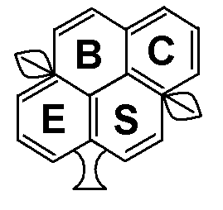  Journal | EVALUATION OF VINASSE, ORGANIC MANURE AND NATURAL MINERALS AS ALTERNATIVE NATURAL FERTILIZERS
 | Wafaa, M. A. Seddik
J. Biol. Chem.  Environ. Sci., 2011,  Vol. 6(4): 13-30  www.acepsag.org | Soil, Water and Environ. Rese. Inst., Agric. Res. Center, Giza, Egypt.
Abstract

A field experiment was carried out for two winter seasons at Ismailia Agric. Res. Station to study the effect of vinasse as well as organic manures (Compost and farmyard) and natural minerals (feldspar, vermiculite and bentonite) on some soil physical and chemical properties and nutritional status of wheat. Two rates of vinasse V1 (2%) and V2 (4%) along with two rates of organic manures {(Comp1 and FYM₁) 5m³ fed⁻¹and (Comp2 and FYM2)10m3 fed-1} and one rate of natural minerals (7 ton fed⁻¹⁾ were used. Results indicate that values of total porosity (TP) and available water (AW) increased but those of decreased bulk density (BD) by addition of vinasse, organic manures and natural minerals compared to control treatments at both studied seasons. Also data demonstrated that increasing rates of vinasse and organic manures significantly increased (TP) and (AW) but decreased (BD) values, the high rate of vinasse (V2) and organic manures (Comp2 and FYM2) along with applied natural minerals being superior .

Available N, P and K in soil increased significantly with application of vinasse especially (V2) rate and organic manures especially (Comp2) rate along with feldspar mineral. Oppositely, the pH values, decreased but those of EC increased with all different studied treatments, the highest values of EC being recorded with bentonite combined with compost and vinasse (Comp2+V2). Concerning OM, values increased with application of different treatments, the highest values exist in case of vermiculite combined with compost (Comp2) and vinasse (V2).

Finally, application of Feldspar minerals combined with compost (Comp2) and vinasse (V2) had recorded the highest values of yield components (straw and grains) as compared to either control or other treatments along with N, P and K total contents.
Keywords: Vinasse, Organic manures, Natural minerals, Soil Physical, Chemical properties, Wheat, Yield.

INTRODUCTION

Vinasse as an industrial waste .It represents the residues from molasses fermentation. Vinasse contains many elements and can be profitably recycled to improve soil properties and increase crop yield with alleviating environmental pollution (Pande et al., 1995). Vinasse improves factors involved in soil fertility, provides favoring conditions for nitrogen assimilation into the soil, protects nutrients against washing out in winter and maintains them as reserve nutrients through slow release during the vegetative period leading to increase yield and quality of crop (Rodriguez, 2000). Vinasse is a final by product of the sugar industry, with great agricultural interest, because of its organic matter content, N and K concentrations (Madejon et al., 2001). Also, vinasse application to sandy soil increased the productivity of wheat yield and uptake of nitrogen, phosphorus and potassium. The residual available N, P and K and organic matter in soil after harvesting generally increased with increasing rate of applied vinasse (Arafat and Abd-Elazim 2002) .Vinasse can partially replace the fertilization that uses potassium and sulfur and partially replace fertilization with nitrogen, a fact that is economically interesting because fertilization with potassium is costly (Luz 2005).
The importance of organic matter to Egyptian agriculture comes directly next to water importance. At the same time, organic manures are added usually to soils to improve their physical, chemical and biological properties and/or provide plants with nutrients. Seddik et.al., (2006) reported that application of natural minerals (bentonite and feldspar in combination with rock phosphate) and organic manure (Farmyard manures and chicken manure) generally decreased the values of soil bulk density, soil reaction pH and EC in spite of increased the micronutrients availability in soil. The bulk density was inferior at application of FYM in combination with 100% bentonite + rock phosphate, an opposite trend being obtained for EC values. In addition, the applied FYM in combination with the rate 75% of bentonite + rock phosphate recorded high values of macronutrients contents, yield components of pea and tomato and high significant increases in available N and p in soil.
Potassium is an element essential for plant growth; with the rapid development of world agriculture, available soil K levels have dropped due to crop removal, leaching, runoff and erosion. Potassium fertilizers played an important role in Egyptian agriculture. The crop production in Egypt relies greatly on imports to meet its annual requirement of potash fertilizers; besides the high cost of conventional water–soluble k fertilizers constrains their use by most of the farmers in the country.
The alternative is depending on expensive imported fertilizers is to exploit k-bearing indigenous resources; this may give a competing capacity for Egyptian agriculture production in international markets and protecting ecological environment. The main source of K for plants growing under natural conditions comes from the weathering of K minerals and organic K- sources such as compost and plant residues. The most important K minerals are K- feldspar, leucite, K–mica such as biotite, phlogopite and glauconite and clays such as illite (Badr, 2006).Potassium from feldspar mineral may be solubilized and transformed into available form when incorporated with organic materials such as (compost). Abd El–Motty et al., (2009) showed that application of feldspar in combination with compost to olive seedlings raised up the macro and micro nutrients percentage in leaves of olive than the control treatment.
Applying feldspar combined with rice straw compost or chicken manure and inoculation with Bacillus pasteurii led to decrease soil bulk density and increase total porosity as well as improve the nutritional status and increase yield of peanut (Seddik, 2006). More recent work by Youssef et al. (2010) showed that addition of feldspar and ammonium nitrate had recorded the highest values of yield components as well as N and K uptake by either peanut or sesame crops in the presence of inoculation with potassium solubilizing bacteria (KSB) than other treatments. Seddlik and Ali (2004) showed that adding vermiculite or bentonite with chicken manure or rice straw compost to sandy soil increased significantly total porosity, available water content, soil field capacity and peanut yield, contrary to bulk density and hydraulic conductivity where their values were significantly decreased.
Bentonite is a natural deposits wide spread in different locations in Egypt and used to overcome the problem of the sandy soils, such as their high bulk density and low levels of water holding capacity, field capacity, available water and fertility. Osman, (2008) found that values of field capacity, wilting point, available water and available N, P and K increased significantly by increasing the rate of organic materials (compost, FYM and compost extract) and natural conditioners (bentonite and dolomite) .

The aim of this work is to study evaluation for effects on vinasse, organic manures and certain natural minerals as alternative natural fertilizers on physical and chemical properties of soil as well as its nutrient availability and nutritional status of wheat.

MATERIALS AND METHODS

Two winter successive field experiments were carried out on wheat (Triticum aestivum L., CV. Giza 168) cultivated on sandy soil under drip irrigation system at Ismailia Agric. Res. station (A.R.C). Some physical and chemical characteristics of the studied soil before cultivation are shown in Table (1).
Table (1) some physical and chemical characteristics of soil samples representing the studied location.
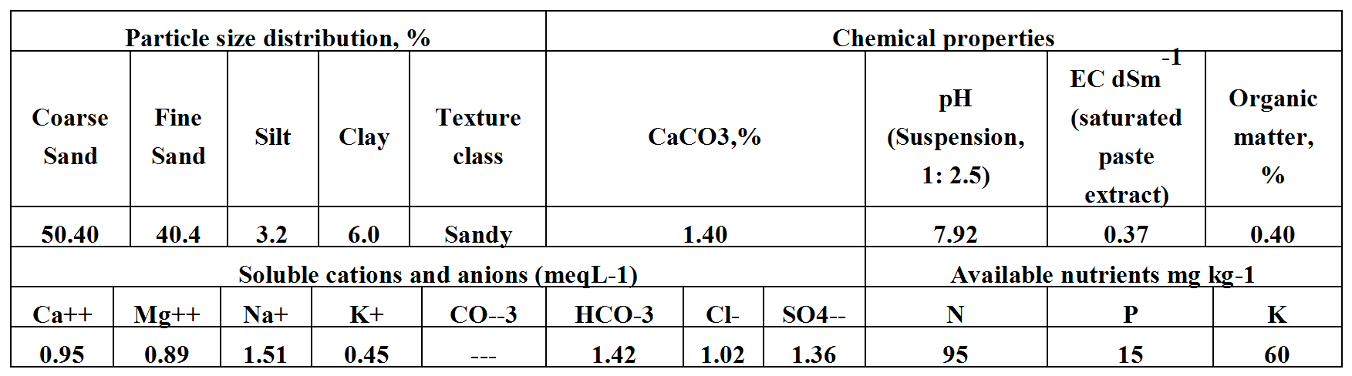

Studied organic manures (rice straw compost and farmyard manure) and natural minerals (feldspar (F), vermiculite (V) and bentonite (B)) constituent's analyses are described in Table (2).

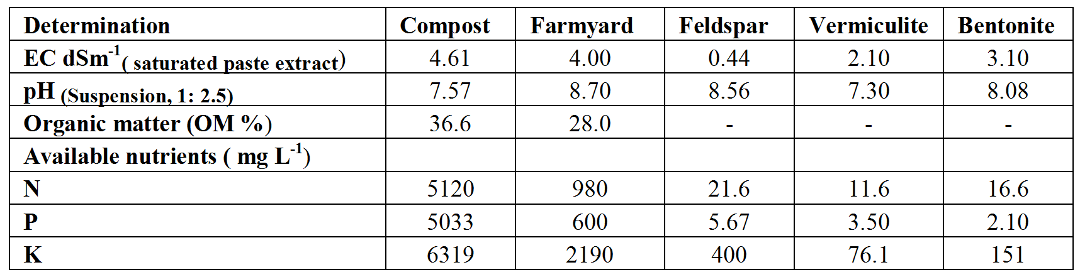
Table (2): Some chemical characteristics of organic manures and natural minerals

Wheat plants were cultivated in a randomized split – split plot design, each treatment being replicated three times. The main plots represented the natural clay minerals (Feldspar, vermiculite and bentonite) which were added at the rate 7 ton fed⁻¹. The sub main plots were for the organic manures (rice straw compost (Comp1, Comp2), and farmyard manure (FYM1, FYM2)) which were added at two rate 5 m³, lo m³fed⁻¹.The sub –sub plots represented the vinasse treatments with two rates of 2% and 4% (V1 and V2) respectively, sprayed weekly on the surface soil layer after wheat cultivation. Concentrated vinasse is provided by integrated industries and sugar CO, EL- Hawamdia, Egypt .Some chemical characteristics of vinasse used in this study are presented in Table (3), some chemical characteristics of diluted being vinasse being presented in Table (4).
Table (3): Some chemical characteristics of vinasse.
Characteristics | Values | Total nutrients%
pH | 4.20 | N | 0.2
EC dsm-1 | 20 | P | 0.4
Total sugar (%) | 59.7 | K | 6.0
Organic carbon % | 3.10
Organic matter % | 6.20
Density (gmL⁻¹) | 1.29

Table (4): Some chemical characteristics of diluted vinasse
Characteristics | Diluted vinasse
Characteristics | (V₁) 2 % | (V₂) 4%
pH | 4.40 | 4.10
EC dsm⁻¹ | 3.57 | 6.73
Available nutrients %
N | 0.080 | 0.100
P | 0.009 | 0.012
K | 3.800 | 5.800

The organic and natural conditioners were added by thoroughly mixing with the surface soil layer only before wheat cultivation. All treatments received mineral fertilizers at 75% from the recommended dose from ammonium sulphate (20.6 % N), super phosphate (15 % P₂O₅) and potassium sulphate (48 % K₂O); control treatment received mineral fertilizers at full dose (100Kg N, 30Kg P₂O₅ and 48Kg K₂O). Wheat plant samples were taken at harvesting stage to determine yield components (straw and grains yield) and nutrient status. Plant samples were oven dried at 70 C for 48 hours, up to constant dry weight, then ground and digested using H₂SO₄ and H₂O₂ mixture described by Page et al. (1982). Soil physical and chemical properties of soil along with analyses for organic manure and natural minerals were evaluated according to Cottenie et al. (1982). Obtained results were subjected to statistical analysis according to Sendecor and Cochran (1982).

RESULTS AND DISCUSSION

I-Soil physical and chemical characteristics.
A-Physical characteristics:
1-Bulk density, total porosity and available water:
Results in Tables (5 and 6) indicated that addition of vinasse (V₁ and V₂) to the soil significantly decreased (BD) values but increased both (TP) and (AW) values as compared to control. These results are similar to those of Tejada et al., (2006) who found that vinasse improved soil physical properties and decreased soil loss. Also data demonstrated significant (BD) decreases but increases in both (TP) and (AW) with increasing rates of vinasse. The high rate of vinasse (V2) was more effective on values of the studied parameters, as compared to low rate of vinasse (V₁) due to its high content of organic matter that increased soil structural stability (Tejada et al,. 2007).
Concerning the effect of organic manures (compost and Farmyard), results indicated general positive effects on (BD), (TP) and (AW) values possibly due to organic matter acts as a cementing factor, necessary for forming stable aggregates. (Tejada et al., 2007).
Regarding the applied organic manures forms, results revealed that significantly decreased (BD) but increased both (TP) and (AW) values, compost being superior as compared to farmyard manure; high rates were more beneficial. These results are in good agreement with those obtained by Tejada et al., (2008) who reported that compost had positive effect of soil physical (structural stability increased 10.5% and bulk density decreased 13.5% in respect to the control soil). High rate of organic manures (compost and Farmyard) was superior in improving (BD), (TP) and (AW) values as compared to low rate. Such results are agreement with Osman et al., (2008).
As for the effect of natural minerals (bentonite, vermiculite and feldspar), data indicated that, for both studied seasons, their application of natural minerals significantly decreased (BD) but increased both (TP) and (AW) values of the studied soil as compared with control. Treatments of natural minerals arranged as follows: Vermiculite > bentonite > feldspar for both (BD) and (TP) values while arranged as follows: feldspar > vermiculite > bentonite for (AW) values.
To make the picture clearer, it was thought useful to express the obtained results as interactions among the influences of vinasse, organic manures and natural minerals, such interactions are shown in Tables (5and6). Data indicated that, values of (BD), (TP) and (AW) at the two studied seasons were most positively affected by application of vinasse, in presence of both organic manures and natural minerals, high rates being generally more effective. These results are similar to those of Tejada et al., (2006, 2007) who found that a good soil structure depended on the content and nature of added organic matter which promotes aggregation of clay minerals.

Table (5): Influence of application of vinasse, organic manures and natural minerals on some soil physical properties.
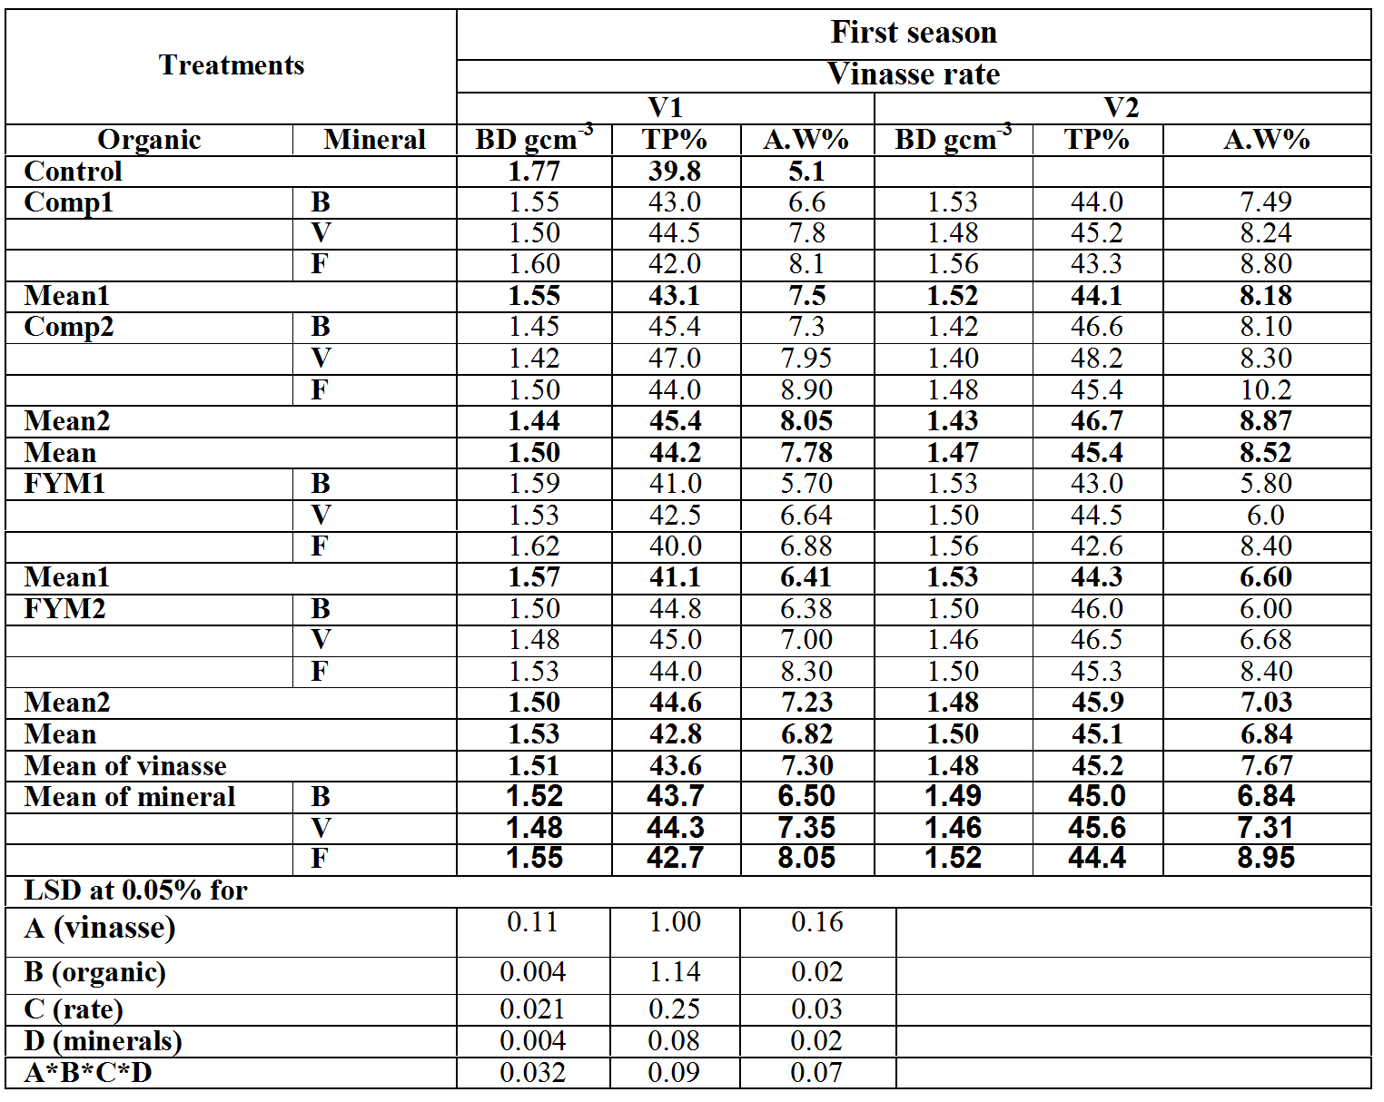
The water higher retention ability of the organic materials, compost, should enhance the soil capability for resaving water (Taha 2007). Also, results showed that, inferior treatment was recorded with (FYM₁) combined with bentonite and feldspar in presence of vinasse (V₁).This inferiority could be due to less organic matter of farmyard manures contains compared to compost and vinasse .

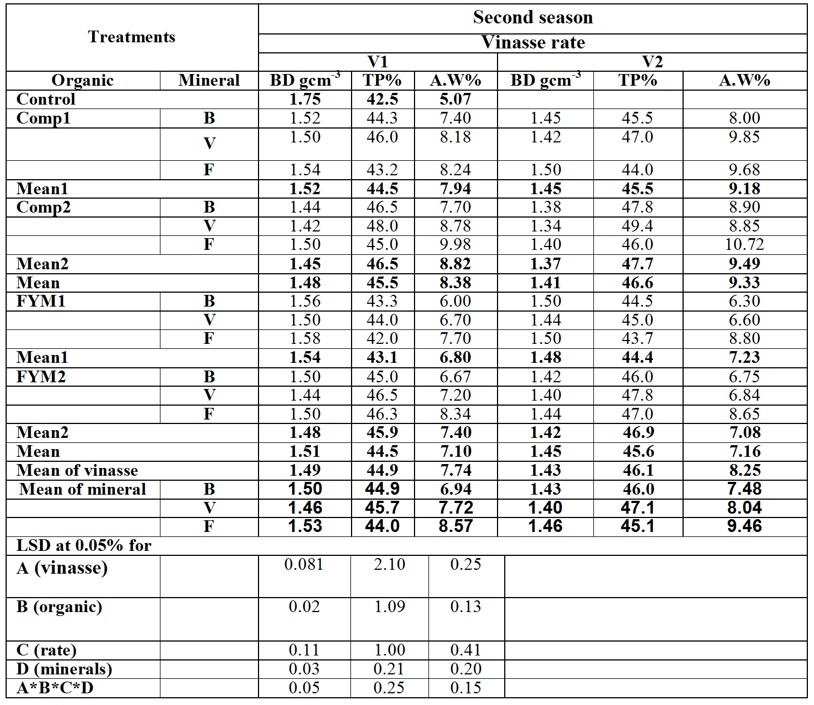
Table (6): Influence of application of vinasse, organic manures and natural minerals on some soil physical properties

B- Chemical characteristics and nutrient availability:
1- Electric conductivity (EC):
Results in Tables (7 and 8) indicted that EC values in soil at both studied seasons increased due to application of vinasse and organic manures (compost and farmyard), the high rates being better. Possibly due to relatively high concentration of dissolved salts in the vinasse especially monovalent cations, particularly Na+, and fulvic acids (Paz et al., 2009).
With respect to interactions Tables (7and8) showed that the highest EC values in soil were reported for bentonite combined with organic manures (Comp2 and FYM2) and vinasse (V2) at both studied seasons. Probably due to the relatively high content of salts in bentonite (Youssef et al., 2010). An opposite trend was encountered with vermiculite particularly when combined with compost (Comp1) and vinasse (V1), which led to a decrease in EC values at the two studied seasons as compared to control possibly due to high cation exchange capacity of vermiculite (100-150 meq/100g) thus ability for adsorption of either protons or organic ligands .
2- Soil reaction pH:
Data presented in Tables (7 and 8) indicated that pH values generally decreased due to application of vinasse , organic manures and natural minerals at both studied seasons; values decreased gradually by increasing the rates of vinasse and organic manures. This may be due to decomposition of organic manures thus producing organic acids that effect PH. This finding agreement with those obtained by Arafat and Abd-Elazim, (2002) as well as Paze et al., (2009). In fact, vinasse is an acidic liquid with pH value between 4 and 5 (Carmen and Pmp, 2006). pH values also decreased with feldspar combined with Comp2 and V2 as compared to other treatments at both studied seasons; these results are similar those of Youssef et al., (2010).
3- Organic matter (OM) %:
Data in Tables (7 and 8) indicated that organic matter content increased with the application of vinasse and organic manures (compost and farmyard) as compared to control; the high rates were superior. Of course, this may be due to relatively high content of N, K and organic matter (Madejon et al., 2001). Such results are agreement with Arafat and Abd-Elazim (2002) who reported that the residual available N, P, K and organic matter in soil after harvesting increased with increasing the rate of vinasse applied.
As for the effect of natural minerals for both seasons indicated that application of different minerals increased (OM) as compared to control. Treatments of natural minerals may be arranged as follows: Vermiculite > Feldspar > bentonite for both studied seasons. Furthermore, results showed that the highest values of organic matter content (OM) exist in case of vermiculite combined with compost (comp2) and vinasse (V2) at both studied seasons. This is may be due to vinasse and compost are high contains organic matter (Madejon et al., 2001). While the lowest (OM) values exist in case of bentonite combined with farmyard manure (FYM1) and vinasse (V1) at both studied seasons.
4- Availability of macronutrients:
Data in Tables (7 and 8) indicated that application of vinasse (V1 and V2) to the soil significantly increased available N, P and K in soil as compared to control treatments, the high rate of vinasse (V2) being superior compared to the low one (V1) possibly due to its high content of N, K and organic matter (Madejon et al., 2001). Such results are agreement with Arafat and Abd-Elazim (2002) who reported that the residual available N, P, K and organic matter in soil after harvesting increased with increasing rate of vinasse applied. Also, vinasse improves factors involved in soil fertility, provides favoring conditions for nitrogen assimilation into the soil, protects nutrients against washing out in winter and maintains them as reserve nutrients through slow release during the vegetative period leading to increase yield and quality of crop (Rodriguez, 2000).
As for the effect of organic manures (compost and farmyard), results indicated that N, P and K availability in soil significantly increased due to application of organic manures (compost and farmyard) ; compost treatments (Comp1 and Comp2) were superior as compared to farmyard treatments (FYM1 and FYM2) probably attributed to relatively higher organic matter content than farmyard.
Concerning the effect of natural minerals, data revealed that feldspar minerals gave the highest values of available N, P and K in soil. Treatments of natural minerals arranged as follows: feldspar > bentonite > vermiculite.
Again, to make the picture more clear, it was thought useful to express the obtained results as interactions among the influences of vinasse, organic manures and natural minerals; such interactions are shown in Tables (7and8).Results, indicated that values were most significantly increased as consequence of applied vinasse in the presence of organic manures and natural minerals. Moreover, results revealed that, feldspar combination with vinasse (V2) and compost (Comp2) being the superior. Vermiculite was recorded as the inferior may be attributed to the wide variety of organic acids during the process of composting carbon acid and chelating substances being also liberated, which helps in K release from feldspar and increase available K in soil. Organic materials reduce N losses and conserve soil N by forming organo – mineral complexes. Soil available K and P increased markedly with organic sources of compost containing feldspar and silicate dissolving bacteria (SDB).The increase in phosphorus could be attributed to mineralization of organic P, solubilization action of certain organic acids and displacement of phosphate with organic anions. The results are in close conformity of work performed by Badr (2006).
Table (7): Influence of application of vinasse, organic manures and natural minerals on chemical properties of the tested soil for both seasons
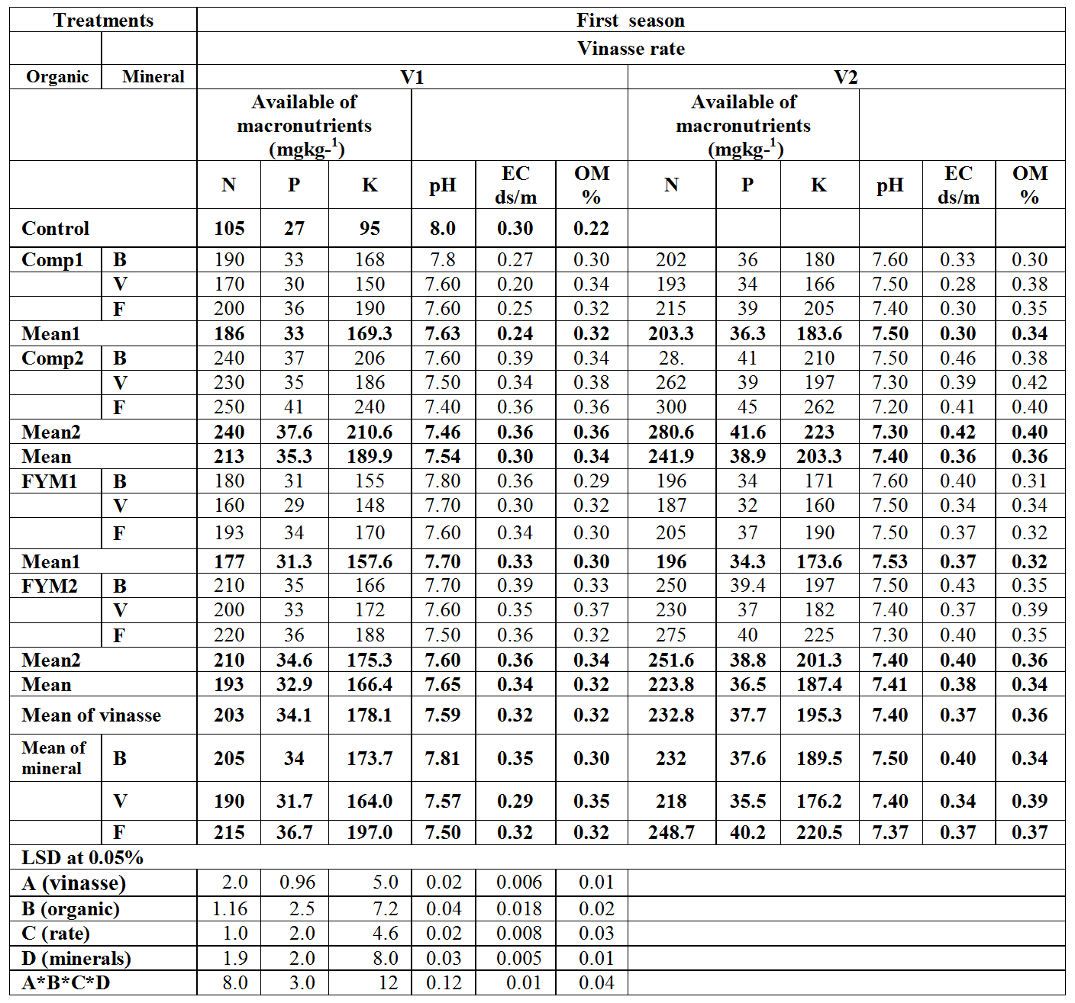
Table (8): Influence of application of vinasse, organic manures and natural minerals on chemical properties of the tested soil for both seasons

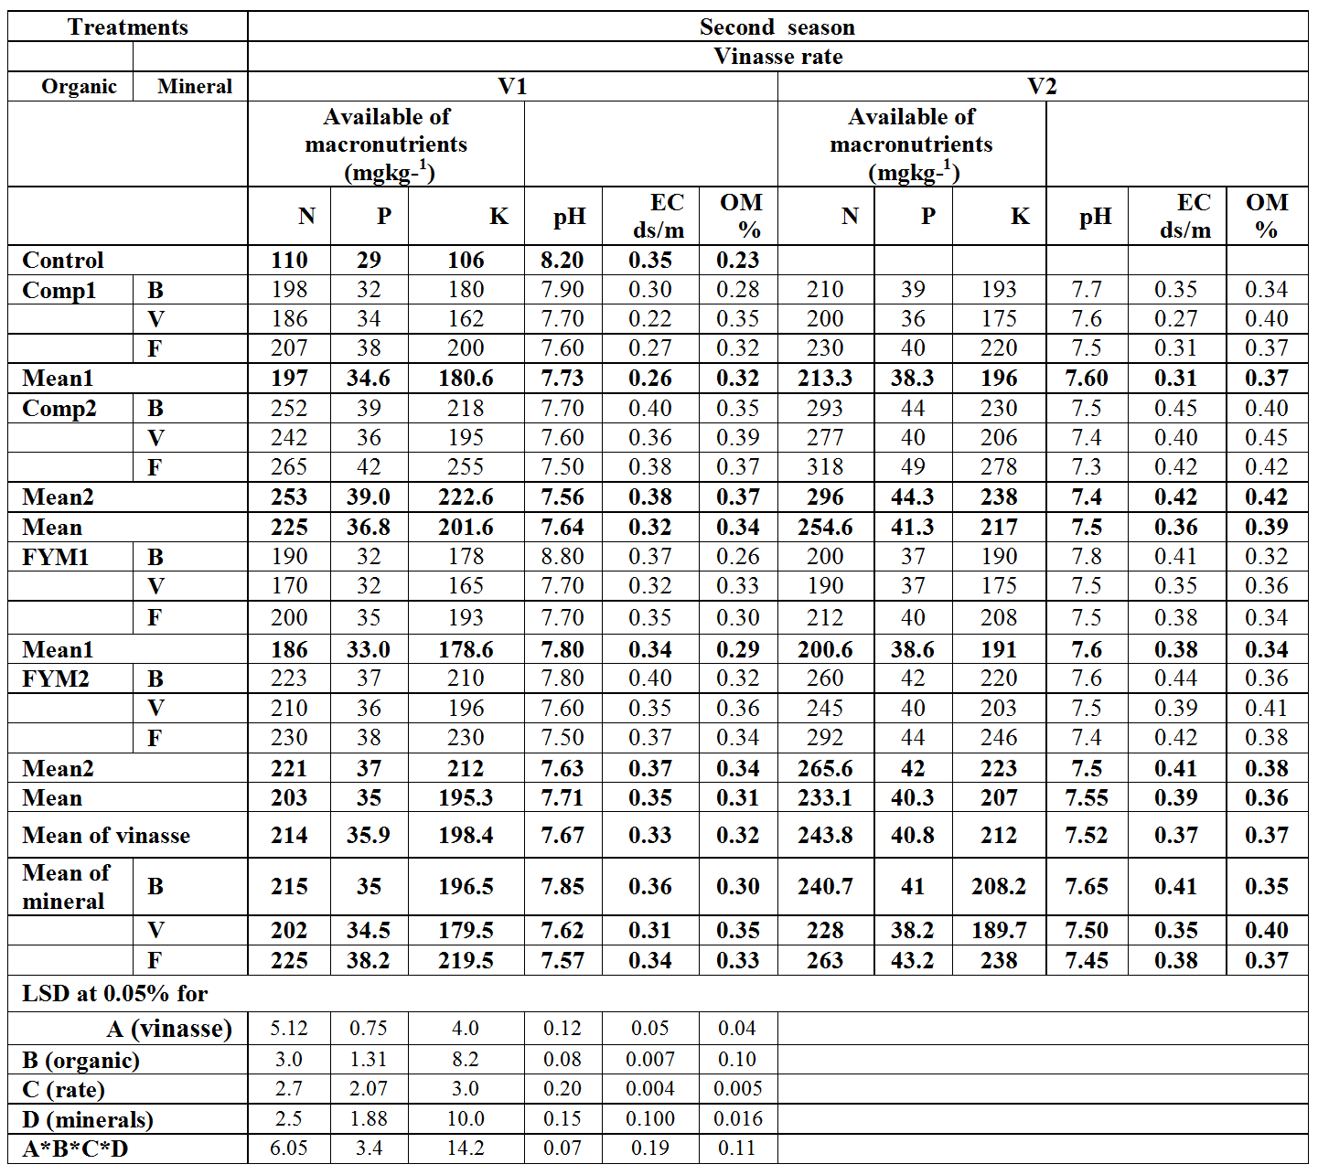

II –Wheat yield components.
Data presented in Table (9) revealed that the values of wheat yield components (grains and straw) at both studied seasons were generally increased significantly for plants receiving vinasse, organic manures (Compost or farmyard) and natural minerals, the high rate of vinasse (V2) being better as compared to low rate (V1). Vinasse application seemed to give better growth due to its effect on physical condition of soil and content of organic matter and nutritional elements needed for plant growth (Arafat and Abd-Elazim 2002).

Table (9): Influence of application of vinasse, organic manures and natural minerals on yield components.
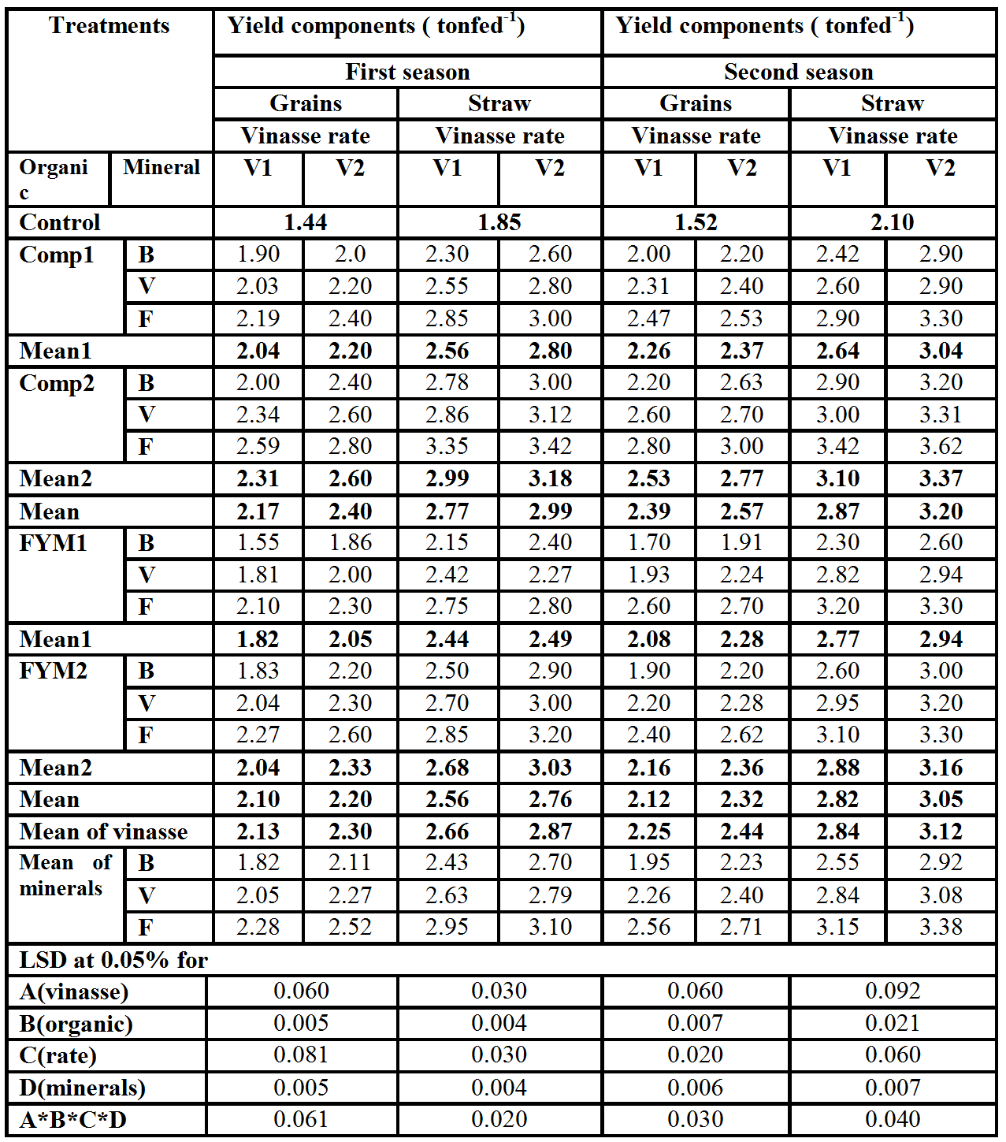

Concerning the effect of organic manures, data showed that grains and straw yield significantly increased due to application of organic manures particularly compost as compared to farmyard manures; high rate was better. This is may be a reflection for improvement of soil physical, chemical and biological properties (Madejon et al 2001). Compost also improves the chemical properties, as well as overall diversity of microbes, provides macro-and micronutrients essential for plant growth and suppress diseases which indirectly contribute to plant growth enhancement (Healther et al., 2006).
Finally, results indicated that yield components (grains and straw) increased significantly due to adding feldspar as compared to other natural minerals at both studied seasons; such minerals arranged as follows: Feldspar > vermiculite > bentonite
Interaction analyses revealed that feldspar combined with compost (especially Comp 2) and vinasse (V2) recorded the highest values of wheat yield components as compared to other treatments. These increases in grains and straw of wheat recorded 93.7% and 84.8% as well as 97.3% and 72.3% respectively as compared to control for first and second seasons, respectively. Of course, compost produce organic acids as result of decomposition with help of present microorganisms; organic acids can directly enhance release K from feldspar by either protons or ligand–mediated mechanisms. They can also indirectly enhance dissolution by the formation of complexes in solution and as a consequence increase the chemical affinity for the overall dissolution reaction (Ullman and Welch 2002). More recent work by Badr, (2006) showed that weathering process of feldspar can be mediated by micro organisms and their metabolites through respiration of plant roots and microbial degradation of organic matter which can increase carbonic acid concentrations in both soil and ground water, leading to an increase in the weathering rates of minerals. In addition to carbonic acid, direct contact between bacteria and minerals may be important in mineral alteration reaction, as microbial surface can complex with metal ions. On the other hand results indicated that the lowest values of wheat yield components were recorded with bentonite combined with (FYM1) and (V1) possibly due to the relatively high content of salts in bentonite (Gouda 1984). More recent work by (Katai et al., 2010) reported that bentonite application to soil reduced the nitrate-N content along with available P and K contents of soil, which should be reflected on nutrients uptake by plants and their yield.

III- Total contents of macro nutrients in grains and straw of wheat:
1 – Nitrogen:
Data presented in Tables (10 and 11) show that nitrogen total content of grains and straw significantly increased by adding vinasse, organic manures and natural minerals as compared to control treatments at both studied seasons. However, high rate of vinasse (V2) recorded the highest values as compared to low rate (V1).
Regarding, the applied organic manures, results indicated that nitrogen total content of grains and straw increased significantly due to adding compost as compared to farmyard manures and control treatments, high rates especially compost being superior at both studied seasons.
As for the effect of natural minerals, results indicated that nitrogen total content of grains and straw increased significantly due to adding feldspar as compared to other minerals at both studied seasons. Treatments of natural minerals arranged as follows:
Feldspar > vermiculite > bentonite for nitrogen total content.
Interactions among the influences of vinasse, organic manures and natural minerals are shown in Tables (7and8). Results indicated that the highest values of nitrogen total content for grains and straw were recorded with feldspar combined with vinasse (V2) and(Comp2) as compared to other treatments. This may be attributed to the beneficial effect of compost and vinasse stimulating micro flora populations, natural hormones and availability of nutrients, also release inorganic ions such as nitrogen but more slowly as the molecules are hydrolyzed or decomposed in the soil, thus reducing losses through leaching. On the other hand, adding vinasse to comp2 + feldspar treatment seemed to supply inorganic N for wheat along the growing period sufficient to meet the N required for crop, especially with application of high rate of vinasse (Arafat and Abd-Elazim 2002). In addition, Rodriguez (2000) found that application of vinasse at the rate of 50 m³h⁻¹ would substitute for 55% N of mineral fertilizers required for sugarcane.
Furthermore, results showed that the lowest value of wheat nitrogen total content existed in case of bentonite combined with farmyard manure (FYM 1) and vinasse (V1) at both studied seasons. These results are in agreement with those of Katai et al., (2010) who indicated that the bentonite depressed the values of nitrate – N content along with available P and K contents of soil, which was reflected on nutrients uptake by plants. Also, behavior of nitrogen uptake followed the same trend of those obtained for yield components at the two studied seasons.
2 – Phosphorus:
Data shown in Tables (10 and 11), revealed that application of vinasse at both rates significantly increased phosphorus total content in grains and straw of wheat as compared to control treatments. Application of organic manures (compost and farmyard) at the two studied rates also increased significantly P total content over control treatment, compost treatment was being superior. Finally, increasing rates of both vinasse and organic manures gave significant increases in the values of P total content in grains and straw. Possibly, due to higher P content applied to soil and increased microbial activity in the rhizosphere. Similar results were obtained by Arafat and Abd-Elazim (2002) who found that increasing rate of added vinasse had a significant increase in N, P and K contents in both straw and grains of wheat.
Interactions among the influences of vinasse, organic manures and natural minerals ,Tables (10 and 11), revealed that the highest value of P total content was recorded in case of applying feldspar combined with vinasse (V2) and compost (Comp2). This may be due to the role of root activity and its exudates as well as decomposition of added compost as to release organic acids favoring the release of P available to plants Duponnois, et al., (2005). The indicated behavior of phosphorus again, seemed to follow a trend similar to those obtained for N total content for the two studied seasons. Finally, the lowest value of P total content was recorded with treatment of bentonite combined with (FYM1) in presence of vinasse (V1).

Table (10): Influence of application of vinasse, organic manures and natural minerals on macronutrients total contents of grains and straw.
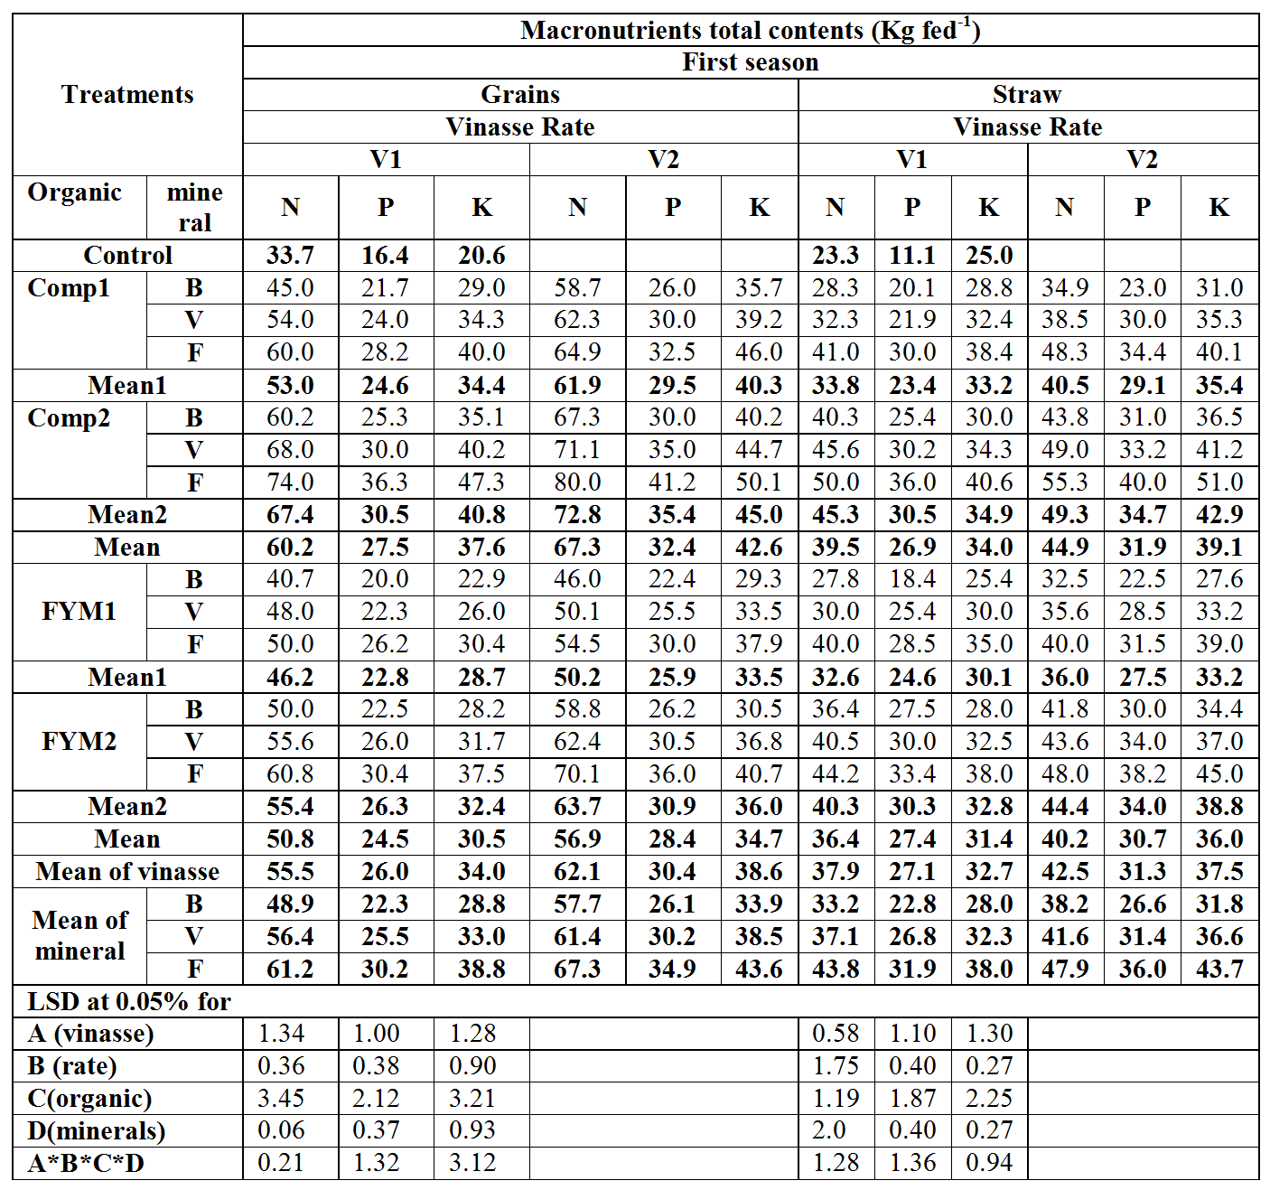

.
Table (11): Influence of application of vinasse, organic manures and natural minerals on macronutrients total contents of grains and straw.
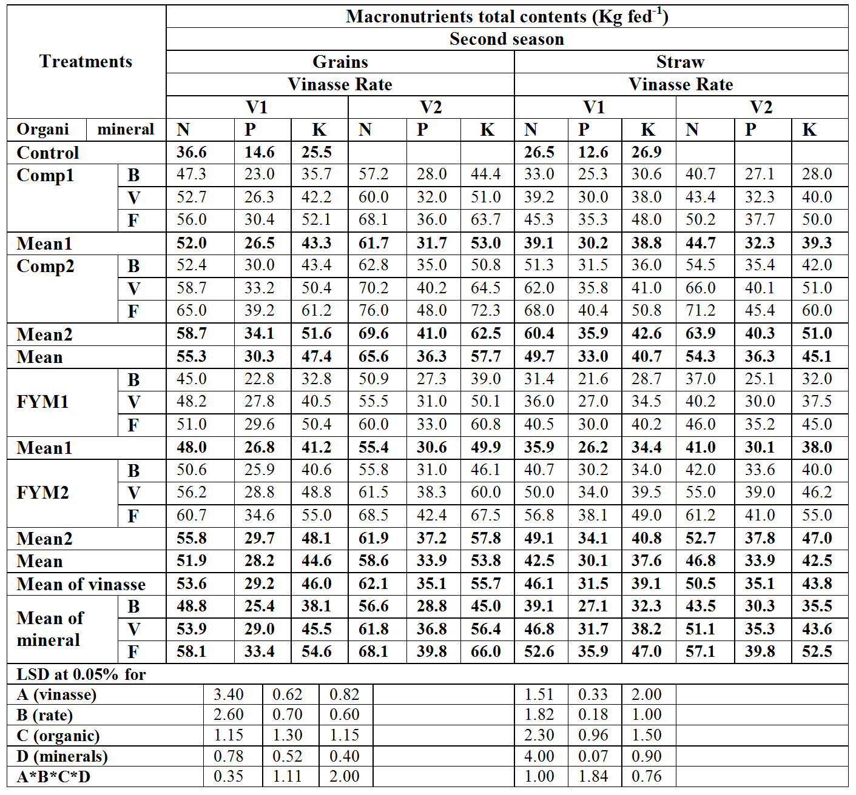

3 – Potassium:
Data presented in Tables (10 and 11) showed that wheat potassium total content in grains and straw of all treatments were significantly increased over control.
Application of vinasse and organic manures was generally superior, high rates being superior possibly due to beneficial effect of vinasse and organic manures on soil physical, chemical and biological properties and high content of organic matter along with nitrogen and potassium (Madejon et. al .2001).
With respect to the effect of natural minerals, results showed that potassium total content for grains and straw significantly increased especially in presence of feldspar as compared to other minerals at the two studied seasons; treatments of natural minerals, could be arranged as Follows: Feldspar > Vermiculite > bentonite. Behavior of potassium seemed to follow a trend similar to those obtained for nitrogen and phosphorus total contents of grains and straw for the two studied seasons.
Again, to make the picture more clear, it was thought useful to express the obtained results as interactions among the influences of vinasse, organic manures and natural minerals, such interactions are shown in Tables (10 and11).Results indicated that values of potassium total content for grains and straw at the two studied seasons, significantly increased as a consequence of applied vinasse in the presence of organic manures and natural minerals as compared to control; the highest values were recorded with feldspar combination with vinasse (V2) and compost (Comp2).
These increases in values of potassium total content of wheat grains and straw recorded 143 % and 104 % against 183 % and 123 % for first and second seasons ,respectively. This could be due to the improvement of soil physical, chemical and biological properties, feldspar being possibly solubilized or weathered under the influence of physical, chemical and biological agents. Biological or bio chemical weathering is made by microorganisms which produce organic acids, phenolic compound and protons. (Duponnois et. al., 2005). Furthermore, microorganisms attached to mineral surfaces can also create micro – environments where concentrations of ligands, acidity can be substantially elevated compared to the bulk solution, thus affecting mineral exchange reactions. Both low and high molecular weight organic ligands were found to be capable of forming strong complexes with AL+3 in solutions and therefore by analogy, with AL–sites on the mineral surface; this has great positive impact on dissolution rates. Al+ forms strong bidentate inner–sphere complexes with many multifunctional organic ligands (such as oxalate) in solution and many of these ligands dramatically affect feldspar dissolution (Bennett and Caseyy 1994).

CONCLUSSIONS
Form the obtained results, it could be concluded that, natural minerals, organic manures and vinasse improved soil physical properties and increased availability of macronutrients in soil. Moreover, feldspar mineral combined with compost (Comp2) and vinasse (V2) recorded the highest values of wheat yield components as well as N, P and K contents of grains and straw wheat.
Finally, potassium from feldspar mineral was solubilized and transformed into available form. The equivalent quantity of K₂O from such fertilizer should be available in three to four times cheaper than imported potash. Moreover, application of compost to feldspar is found to be economical as well as eco – friendly, no leaching loses of nutrients being obvious from feldspar. Also, vinasse had direct effect as a good replacement for mineral fertilizers, and an indirect effect consisting of an improvement for utilization of absorbed nutrients.

Thus, the importance of the use of natural minerals especially feldspar and compost combined with vinasse should be considered to be natural alternatives fertilizers and beneficial cheap sources of fertilization for sustainable agriculture in sandy soils.

REFERENCES

Abd El – Motty, Elham Z., M. F. M. Shahin, M. M. M. Abd – El Migeed and A F sahib, (2009). Comparative studies of using compost combined with plant guard and feldspar and the morphological, physiological and Rhizo spheric microflora of olive seedling. J. Agric. and Environ. Sci. 6: 372 – 380.
Arafat S. and Y. Abd – Elazim (2002). Agronomic evaluation of fertilizing efficiency. Symposium no. 14. 17th WCSS, 14 – 21 August 2002 Thailand. 1991 – 1 1991 -6
Badr, M. A. (2006). Efficiency of K – feldspar combined with organic materials and silicate dissolving bacteria on tomato yield. J. Appl. Sci. Res. 2: 1191 – 1198.
Bennett, P. C. and W. H .Caseyy, (1994). ''Chemistry and mechanisms of low temperature dissolution of silicates by organic acids''. Springer verlag, Berlin, PP: 162 – 200.
Carmen B. S. and P. E .Pmp, (2006). Anaerobic digestion of vinasse for the production of methan in the sugar can distillery. "Conference on sugar processing" Loxahatchee, Florida, USA.
Cottenie, A., M. Verloo, L. Kiekns, G.Velghe and R. Camerlynek (1982). Chemical analysis of plant and soils Lab. Analy. and Agroch St. State Univ., Ghent, Belgium.
Duponnois, R. C., A .H. victor and T. Jean, (2005). The mycorrhizal fungus, Glomus intraradices and rook phosphate amendment influence plant growth and microbial activity in the rhizosbhere of Acacia holoserica. J. soil Biol. Biochem., 37: 1460 – 1468.
Gouda,M.A.(1984). Soil and water management of sandy soils.ph.D Thesis,Fac.of Agric.,Zagazig Univ.,Egypt.
Healther, M. D., G. S. Alexandra and P. D. Richard, (2006). Compost and manure mediated impacts on soil borne pathogens and soil quality. Soil Sci.Soci. Amer.J., 70:347-358.
Katai, J., M. Tallai, 25. Sandor and O. A. Zsuposne, (2010). Effect of bentonite and zeolite on some characteristics of acidic sandy soil and on the biomass of a test plant. Agrokemia es Talajtan. 59: 165 – 174.
LUZ, P.H.C., (2005) ''Novas Tecnologiasno Uso de Vinhacae Alguns Aspectos legais,'' ll simpsio de Tecnologia de produce de Accar, Pirassunuga, S. paulo, 53 P.
Madejon, E., R. Lopez, J .M. Murillo, and F. Cabrea. (2001). Agricultural use of three. (Sugar beet) vinasse composts: Effect on crops and chemical properties of a Cambisol soil in the Guadalquivir River Valley (SW Spain). Agric. Ecosystem. Environ. 84: 53: 65.
Osman, Mona A., Wafaa M .A. Seddik and Gehan H. Youssef (2008). Effect of som organic and natural conditioners addition on physical and chemical properies of soil, its nutritional status and Zea Maiz Yield. J. Agric. Sci., Mansoura Univ., Egypt. 33: 9183 – 9194.
Page, A.L.; R.H., Miller and D.R., Keeney. (1982). "Methods of soil analysis" Amer. Soc. Agron. ,Madison, Wisconsin, U.S.A.
Pand H. P., B. K. Sinha, G. B. Singh and S. Solomons. (1995). Use of distillery waste as a fertilizer. sugarcane: Agro – industrial AL ternatives , P . 401 – 413.
Paz, C .B. J. A. M. Rubi, R. G. Gimenez and R. J. Ballesta, (2009). Impact caused by the addition of win vinasse on some chemical and mineralogical properties of a luvisol and a vertisol in La Mancha (control spain) Journal of soil and sediments. 9: 121 – 128.
Rodriguez, J. G., (2000). Effect of vinasse on sugarcane (Saccharum officinarum) productivity. Rev. Fac. Argon., 17: 318 – 326.
Seddik Wafaa M. A and Laila K. M. Ali (2004). Effect of some natural soil amendments on some soil physical properties, peanut and carrot yields in sandy soil. J. Agric. Res.,Egypt. 82: 95 – 105.
Seddik, Wafaa M. A. (2006). Effect of organic manures and feldspar application on some sandy soil physical and chemical properties and their refection on peanut productivity. J. Agric. Sci., Mansoura Univ., Egypt. 33; 6675 – 6687.
Seddik Wafaa M. A., Gehan H. Youssef and Mona H. M. kenawy (2006). Changes in soil physico–chemical properties and macronutrients contents of pea and tomato plants due to organic manure and some natural minerals fertilization. J. Agric. Sci., Mansoura Univ., Egypt. 31: 7347 – 7362.
Sendecor, G. W. and W. G. Cochran. (1982).'' Statistical Methods''. 7th edition, Iowa State Univ. Press, Ames., IA., USA.
Taha, M. B. (2007). Recycling of organic wastes for using as amendments. Ph. D. Thesis. Fac. Agric, Minia Univ, Egypt.
Tejada M., C. Garcia,J.L.Gonzalez and M.T.Hernandez (2006). organic amendment based on fresh and composted beet vinasse: Influence on soil properties and wheat yield. Soil Sci.Soci. Amer.J., 70:900-908.
Tejada M., J. L. Moreno, M. T. Hernandez, C. Garcia (2007). Application of two beet vinasse forms in soil restoration: Effects on soil properties in an arid environment in southern Spain. Agriculture, Eco systems and environment 119; 289 – 298.
Tejada M., J.L.Gonzalez, A.M. Garcia-Martinez and J.Parrado (2008). Application of green manure and green manure composted with beet vinasse on soil restoration: Effects on soil properties.Bioresources Technology 99:4949-4957.
Ullman, W. J. and S. A. Welch, (2002). Organic ligands and feldspar dissolution. The geochemist. Soc., 7: 3 – 35.
Youssef, Gehan H., Wafaa M .A. Seddik and Mona .A. Osman (2010). Efficiency of Natural minerals in presence of different nitrogen forms and potassium dissolving bacteria on peanut and sesame yields. J. Amer. Sci. 6: 647 – 660.

تقييم الفيناس والمخلفات العضوية والمعادن الطبيعية
كأسمدة طبيعية بديلة
وفاء محمد أحمد صديق
معهد بحوث الأراضي والمياه والبيئة- مركز البحوث الزراعية- الجيزة- مصر.

أجريت تجربة حقلية في موسميين شتويين متعاقبين على محصول القمح بمحطة البحوث الزراعية بالاسماعيلية- مركز البحوث الزراعية- لدراسة تأثير اضافة الفيناس والمخلفات العضوية مع معادن الفلسبار-الفيرميكوليت-البنتونيت على الخواص الطبيعية والكيميائية للتربة والحالة الغذائية للقمح. تم استخدام معدلين من الفيناس (V₁ 2%,V₂4%) و نوعين من المخلفات العضوية(كمبوست وسماد بلدى) بمعدلين 5م3و10م3/ فدان مع ثلاث أنواع من المعادن الطبيعية (فلسبار- فيرميكوليت- بنتونيت) بمعدل 7 طن/فدان .
لقد أشارت النتائج الى زيادة قيم الماء الميسر والمسامية الكلية وانخفاض الكثافة الظاهرية نتيجة اضافة الفيناس والمخلفات العضوية و المعادن الطبيعية بالمقارنة بمعاملة الكنترول وذلك في كلا الموسمين تحت الدراسةخاصة بزيادة معدل الفيناس والمخلفات العضوية
أيضا اضافة المعدل الثانى من الفيناس(4%)و المعدل الثانى من الكمبوست(10مم3/ف) و معادن فيرميكوليت- بنتونيت- فلسبار كانت مميزة لقيم الصفات تحت الدراسة فى كلا الموسميين المذكورين.
أيضا اشارت النتائج الى زيادة معنوية فى العناصر الميسرة من النيتروجين والفوسفور والبوتاسيوم فى التربة باضافة الفيناس والكمبوست خاصة مع المعدل الثانى لكلا منهما .وأعلى زيادة من العناصر الميسرة من النيتروجين والفوسفور والبوتاسيوم فى التربة سجلت مع معاملة الفيناس (المعدل الثانى ( + الكمبوست (المعدل الثانى ( + معدن الفلسبار.
اشارت النتائج الى أن قيم "EC" تزيد وقيم ال pH تقل مع المعاملات المختلفة بحيث سجلت معاملة البنتونيت مع المعدل الثانى للفيناس والكمبوست اعلى قيم التوصيل الكهربى فى كلا الموسميين. أما بالنسبة لقيم المادة العضوية فقد زادت مع اضافة المعاملات المختلفة بحيث سجلت معاملة الفيرميكوليت مع المعدل الثانى للفيناس والكمبوست اعلى قيم المادة العضوية.
أخيرأ اشارت النتائج الى أن اضافة معدن الفلسبار مع المعدل الثانى من كلا من الفيناس والكمبوست سجلت اعلى قيم لمكونات محصول القمح (حبوب وقش) بالمقارنة بمعاملة الكنترول والمعاملات الاخرى. هذه الزيادة في الحبوب والقش سجلت 93.7% و 84.8% وكذلك 97.3% و72.3% للموسم الاول والثانى على التوالى. وفيما يتعلق بالمحتوى الكلى لعناصر النيتروجين والفوسفور والبوتاسيوم فى الحبوب والقش لمحصول القمح , اتبعت نفس المسار لمكونات المحصول.

